Little Kids, Big Adventures: A Guide to Family Hikes Around Knoxville

Katie Rosenberg and Joshua Rosenberg

2025-01-14

Table of contents

# Preface

### A story about a hike

|  |  |
| --- | --- |
|  | Please note - this book is in-progress, and many sections are not yet drafted or are in draft form! It is set to be published by [UT Press](https://utpress.org/) with an expected publication date in early 2026. |

|  |
| --- |
| Photo credit to Katie and Joshua Rosenberg |

Photo credit to Katie and Joshua Rosenberg

Picture this: A sunny day in nature with your family. Your kids happily climb up and over rocks, stopping only splash in creeks. At the end, you have a picnic on the grass on a perfect, mild but warm day, without a bug to be found.

*Record Scratch*

Sure, we’d all love for the above vision to be reality, but the truth is almost always a bit messier and with unexpected bumps in the road.

If you’re like us, you might be ready to throw in the towel before you even leave from home. We’ve been there.

However, we’ve also grown as a family who hikes, honed in on the process, and adjusted our expectations. And sometimes the weather is just right, we and the kiddos are having a great time, and, every once in a while, there really isn’t a bug in sight.

|  |
| --- |
| Photo credit to Sam Weisbrod |

Photo credit to Sam Weisbrod

### We wrote this to help our friends (and you!)

After moving to Knoxville as a very young famiy in 2018, our first trip to Ijams introduced us to Knoxville’s incredible outdoor spaces. A camping trip at Frozen Head opened our eyes. Later, visiting the Smokies sealed the deal: hiking helped us to feel connected and later to love where we live.

We don’t think we’re very special in this respect (and in most others!): One of the many joys of writing this book was discovering that we’d hiked all 30 of the trails in it.

As we transitioned from newcomers to becoming established, we were increasingly asked questions by our friends:

*Where should we hike with our kids?*

and

*What do I need to hike with our kids?*

This book is meant to answer those questions. But, as a sneak preview, we picked out 30 trails with an eye not only toward the trails that are scenic and exciting, but also those that are likely to balance driving distance, crowds, and kid-friendly characteristics. And, one of the many great parts about hiking is that you don’t need much to get started. Indeed, you may not need anything at all.

### Who this book is for

This book is for families and others caring for children who are looking for an accessible introduction to getting started hiking around Knoxville. Furthermore, this book is also for those who with a few favorite trails looking to do and learn more—find longer, more challenging hikes, or be introduced to hidden gems.

Because this book is for those new to hiking and those with some mud on their shoes, we’ve included a wide range of hikes, from those shorter than a mile on paved trails to epic expeditions into the Smokies. Additionally, we’ve noted trails that are stroller-friendly or accessible for families with additional needs.

|  |
| --- |
| Photo credit to Katie and Joshua Rosenberg |

Photo credit to Katie and Joshua Rosenberg

### Where the hikes are

All of the hikes are near Knoxville—from just a few minutes to within an hour or two drive (but no longer). Following our focus on hiking with younger children, most of the hikes are within an hour’s drive of Knoxville.

They are in three regions:

* **In and around Knoxville**: Hikes within the Knoxville city limits, to those within a 30-minute drive.
* **The Cumberland Plateau**: An often under-appreciated but fantastic region of rock outcroppings and wild rivers to the West and North of Knoxville. The hikes in this book are from around one to two hours from Knoxville, with most being close to one hour.
* **The Great Smoky Mountains National Park**: The most-visited and the most biodiverse national park—right in Knoxville’s backyard. These are mostly around an hour from Knoxville, though a few are closer to two hours.

# Getting Ready for Your First Hike

### You don’t need fancy gear!

There’s a little secret in the hiking world. You don’t need a lot to get started. Indeed, may not need anything *new* at all.

Our view is that you don’t need anything special to enjoy your first hike. With the right trail and a few basics, you’ll be ready for an adventure.

First, though, there’s another little secret we need to share.

### You don’t need to be an experienced hiker to hike with little ones

Hiking can be different from other physical activities in that it is not a competition. Instead, it is about experiencing the outdoors in our own way.

This applies to beginners and to the most experienced hikers; a common saying shared among long-distance hikers is to *hike your own hike.* This means that each person hiking will hike in their way, and that there is not anything like a correct way to lace up your shoes and to get outdoors with your family. If this applies to long-distance hikers, we think it doubly applies to families hiking with littles! Hike your own hike.

|  |
| --- |
| Photo Credit to Sam Weisbrod |

Photo Credit to Sam Weisbrod

### Let kids take the lead

To help your kids develop a love for hiking and the outdoors, let them take the lead. Let them develop their own interests and explore their own curiosities when you go on a hike. Sometimes this might mean playing in a creek for half of your planned hiking time.

|  |
| --- |
| Photo credit to Katie and Joshua Rosenberg |

Photo credit to Katie and Joshua Rosenberg

### Be choosy about the when and where

One of the benefits of living close to great hiking opportunities is that we can be a little choosy about when and where we hike. While we are card carrying members of the puddle splashing club, we also appreciate that our littles may have a better time when it is not 50 °F and rainy. Does it look like it is going to rain all day, border on being too cold, or be oppressively hot? You can choose another day to hike; we have enough good weather that we can avoid the less-than-ideal days.

|  |
| --- |
| Photo credit to Katie and Joshua Rosenberg |

Photo credit to Katie and Joshua Rosenberg

### Plan for the essentials

At a minimum, the following items are essential for hikes when the weather is good and you are close to home:

* Water
* Snacks
* A waist pack or backpack

Older kids may like to carry some of these—especially the snacks!

|  |
| --- |
| Photo credit to Sam Weisbrod |

Photo credit to Sam Weisbrod

When taking on a lengthier hike or traveling farther from home, the following can be helpful:

* A change of clothes, including socks
* A jacket or additional layers for warmth
* A towel
* Shoes with some traction (though what are strictly called hiking shoes are not needed)
* A first aid kit

The appendix has some recommendations for a basic first-aid kit as well as recommendations for some additional items you may optionally wish to bring.

### Embrace serendipity

It’s good to have a plan, but don’t be surprised if something better comes along! Maybe you hike further than you thought you would, or perhaps your child surprises you (and themselves!) by taking some time to rock hop across a creek, follow animal tracks, or look at plants and flowers. Be ready to follow your child’s lead—whether that means stopping to watch a butterfly or counting animal tracks. These moments often become the most cherished.

### Select advice

We asked some local hiking experts to share some additional advice. Here’s what they said:

* “Kids need to find things they love on hiking.” - Finn (3)
* “Find rocks while hiking.” - Ruth (5)
* “When possible, swim in the waterfalls.” - Ruth (5)
* “It’s important to go off the trail.” - Ruth (5)
* “If your baby can walk a little bit, then let them walk.” - Jonah (age 6)
* “Make sure to run and also look for bears.” - Levi (7)
* “You might want to bring pants and a sweatshirt with a hood. Because that one time I brought no pants and a sweatshirt with no hood.” - G.H. (9)

The next chapter offers some guidance on how to pick a trail (and how to use this book).

# Finding a Hike

Lists of *the best* hikes are helpful, but they can lead you to trails that are far away, crowded, and not suited to young kids. Furthermore, what even is *the best* trail to kids?

We bet you’ve had the experience on a family trip to someplace special only for your kiddo to be captivated by the stairs near the entrance—or, you bought a pricey gift only for the cardboard box to be the best part.

There’s something similar when it comes to finding a hike: Which hike is the best can be really hard to predict in advance!

Still, we think you can set yourself up for success: We picked the hikes that are in the sweet spot for parents of younger children: not too far away, not so challenging so as to be discouraging to kids and their parents; near amenities; and being scenic and rewarding to accomplish.

### Choosing where to hike

Some trails are short, flat, and on a paved surface. Others are longer, steeper, or rockier. How do you find which one is best for you?

|  |
| --- |
| Photo credit to Katie and Joshua Rosenberg |

Photo credit to Katie and Joshua Rosenberg

This book has three sections, one each for hikes in and around Knoxville, on the Cumberland Plateau, and in the Great Smoky Mountains National Park. Within each section, we organized loosely along the lines of those we’d recommend first.

Thus, the first few hikes in each section are what we think of as “sure bets”. Get the weather right, pack a bunch of snacks, and we think you’ll likely have a good time. We also created a list of Top 5 Hikes that can help with choosing where to first hike.

For example, Seven Islands in Knoxville is a reliable choice with paved paths, beautiful views, and plenty of spots for kids to explore. Indeed, if you haven’t hiked there yet and the weather is good, we recommend you stop reading now and head out!

### Some help with choosing

In addition to the trails at the start of each section, each trail in this book includes an overview and the approximate driving distance from Knoxville, the length of the hike, and for which ages the hike is best. Check those out to find one that’s best for you.

Additionally, the chapters include a description, directions to the trailhead. We also include a map of the trail, and a note about what’s nearby.

We wrote the overviews of each hike with the reader looking to get an overall sense for the “look and feel” of the hike. Skim those for inspiration and ideas. After each overview is a table with key characteristics of the trail, including the approximate distance from Knoxville (calculated from the city center) and for which ages of children the hike is best.

The trail maps should be pretty straightforward to use. Trailheads—the starting points for the hikes—are marked with a green dot, and the trail is in red, with key features of the trail noted along the way.

The hikes are through areas rich in natural and human history, and while we felt comfortable accurately describing many of these elements, we felt we had to enlist the help of friends and colleagues for others. Note these callouts, many written by those with expertise in the sepcific scientific or historical feature. Look for these in the call-outs in most of the chapters, and consider sharing parts of them with your little hikers.

### Let’s go!

That’s all—you’re ready for your first hike! See you on the trails!

# Trail 1: Seven Islands

### Overview

This is one of our favorite trails in this book, and it is the first trail for that reason! This hike is a crowd pleaser for every family member of all ages thanks to a paved path that makes bringing babies in a stroller a breeze and easy acces to experience meadow, woodland, and a river! For the trail we highlight, a paved path descends through a meadow. Look for varied bird varieties and deer in all seasons! The trail crosses a bridge over the French Broad River and then a dirt trail make a loop around a beautiful island before returning back to the paved path. This hike is great for all ages and seasons, though it is sometimes hot in the summer due to limited shade on the paved part of the trail.

|  |
| --- |
| Photo credit to Katie and Joshua Rosenberg |

Photo credit to Katie and Joshua Rosenberg

### Key Characteristics

| **Characteristic** | **Details** |
| --- | --- |
| Time Estimate - Hiking Fast | 1.5 - 3 hours |
| Trail Distance (Miles) | 2.3 |
| Elevation Change | Gentle |
| Pets | Allowed on leash |
| Parking Pass/Entrance Fee | Not Required |
| Restroom(s) | Yes |
| Best Ages |  |
| Strollers and Wheelchairs |  |

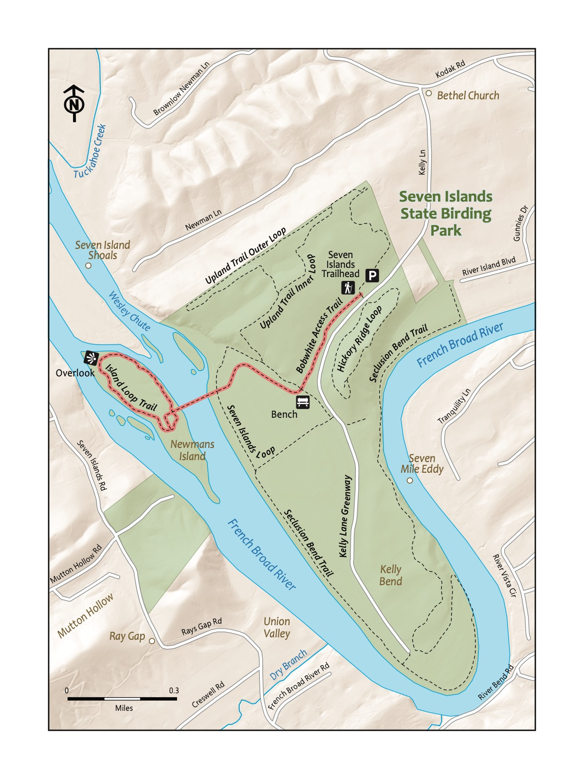

### Directions to the Trailhead

Trailhead Address: Seven Islands State Birding Park, 2809 Kelly Ln, Kodak, TN 37764

Trailhead GPS Coordinates: 35.95366, -83.68701

Park in the large gravel lot (note there is another parking area by a boat launch that is not the correct location for this hike!). We have never had trouble finding a spot even on the busiest of days.

|  |  |
| --- | --- |
|  | **Paw Paw**  A native fruit found around Seven Islands. Tastes like a mix of an apple and a banana. Paw Paw flowers are pollinated by beetles and flies. |

### Trail Description

| Distance from Start | Description |
| --- | --- |
| 0.0 | Access the Bobwhite Access Trail by walking around or through the barn. |
| 0.05 | Bathroom on the left of the trail. |
| 0.1 | Descend through grassy meadows with wildflowers in the spring and early fall. |
| 0.3 | Bench makes for a nice rest spot. |
| 0.6 | Start of the Newmans Island Bridge. |
| 0.8 | Paved trail ends. Turn right onto the Island Loop Trail to hike around the island. |
| 0.85 | Picnic table beside a pretty part of the French Broad River. |
| 1.05 | Stick house (kiddo favorite!). |
| 1.5 | Connect back to the bridge, heading back onto the Bobwhite Access Trail. |
| 2 | Climb back up the Bobwhite Access Trail to the trailhead. |
| 2.3 | Trailhead. |

### Nearby

|  |  |
| --- | --- |
|  | **Eastern Bluebird**  While many birds stop over at Seven Islands and areas like that on their migratory routes south (in the fall) and north (in the spring), the Eastern Bluebird is a year-round resident. Bluebirds are obligate cavity nesters - which is why they have experienced such a decline in their population as urban sprawl has increased. Refuges like Seven Islands give them lots of opportunities to find natural cavities to nest in! -MaryRose Weatherton |

* **Take advantage of the other trails nearby!** Hike up the Hickory Ridge trail, another trail at Seven Islands State Birding Park, that is accessible from just behind the bathrooms near the parking lot. There are several other great hikes available, including hikes down the Kelly Lane Greenway (the other, wider, paved path near the barn that is gated to prevent cars from driving on it) and the Upland Inner and Outer Trail Loops.
* **Bring your canoe, kayak, or paddle board for even more adventures!** Access parking by Also, River Sports Outfitters rents kayaks and canoes here during the summer (see https://www.riversportsoutfitters.com/).
* **Stop for a bite to eat and a drink on the way back!** Consider stopping by kid-friendly Walnut Springs Winery (1175 Midway Rd, Knoxville, TN 37914), open Wednesday-Sunday as of this writing.

# Trail 2: Ijams Riverside

### Overview

It’s easy to take this destination for granted if you live in Knoxville – we seem to find something new every time we visit! Bring along your baby carrier for this hike, which is meant to be a gentle introduction to what Ijams refers to as the Riverside area. The trail starts by the Ijams Nature Center’s visitor center and meanders down through a deep forest to the river. It continues along the boardwalk trail that happens to follow the side of the very first mile of the Tennessee River. The trail returns back up and over a rocky ridge to return to the visitor center. Ijams offers multiple play areas and links to other trails nearby, so you can make a day of it!

|  |
| --- |
| Photo credit to Katie and Joshua Rosenberg |

Photo credit to Katie and Joshua Rosenberg

### Key Characteristics

| **Characteristic** | **Details** |
| --- | --- |
| Time Estimate | 45 minutes - 1.5 hours |
| Trail Distance (Miles) | 1.03 |
| Elevation Change | Moderate |
| Pets | Allowed on leash |
| Parking Pass/Entrance Fee | Required (pay on site) |
| Restroom(s) | Yes |
| Best Ages |  |

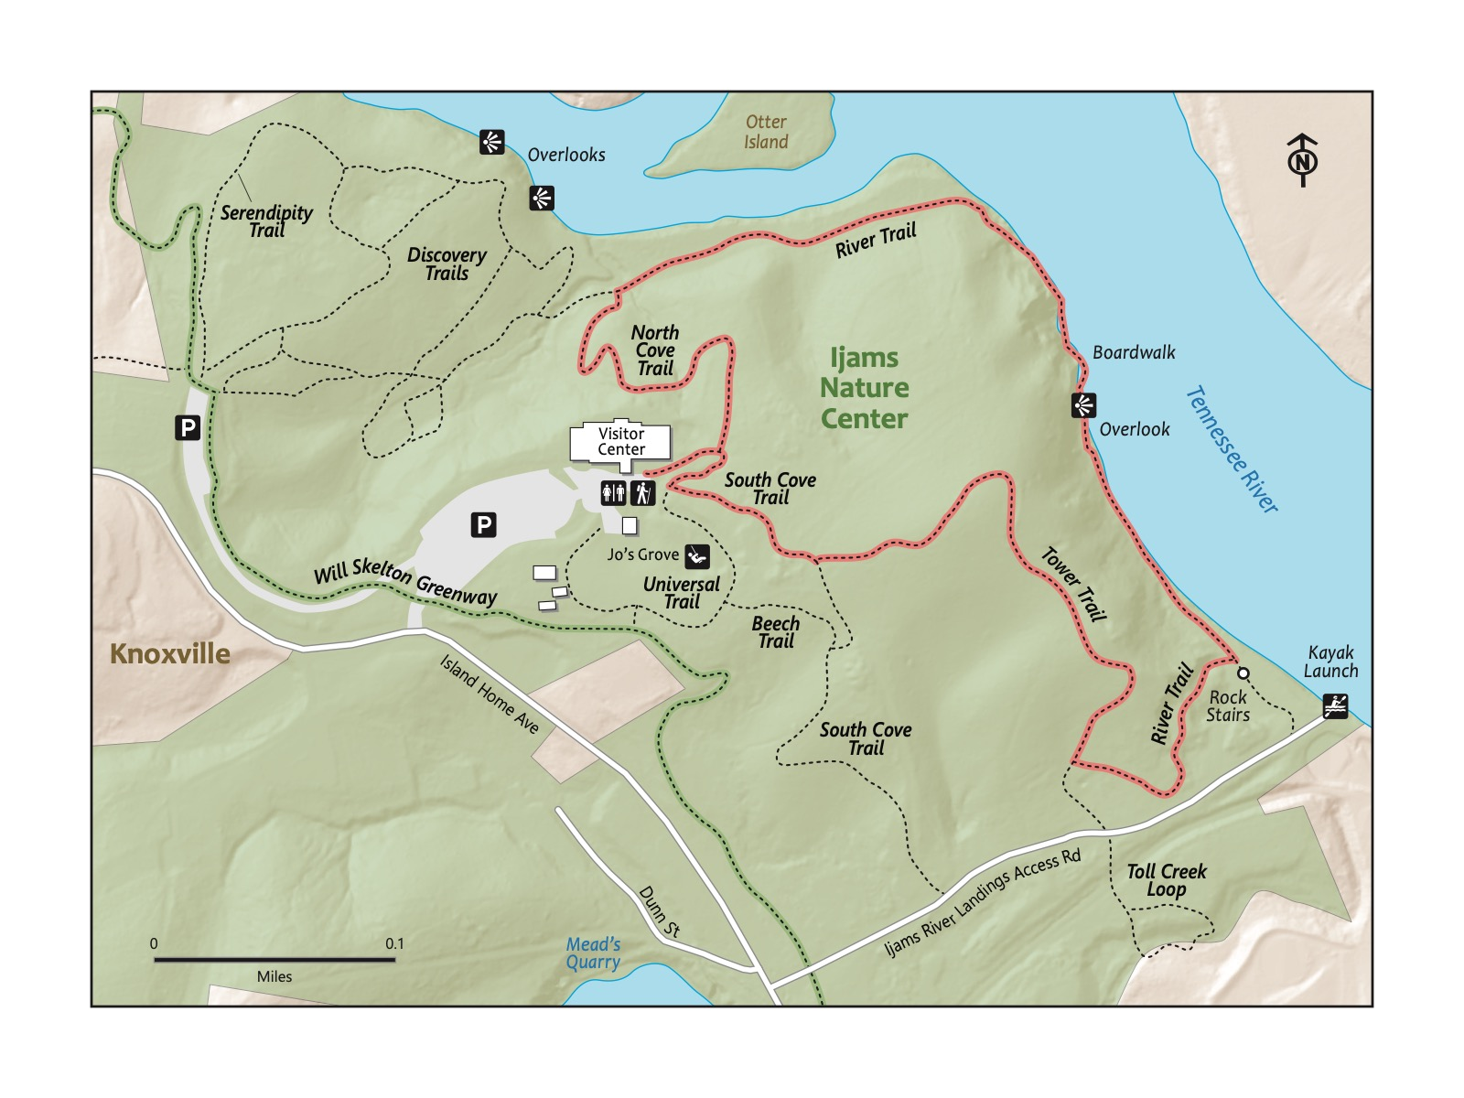

### Directions to the Trailhead

Trailhead Address: Ijams Nature Center, 2915 Island Home Ave, Knoxville, TN 37920

Trailhead GPS Coordinates: 35.95612, -83.86725

Use the above address to easily navigate to the parking area. Park in the large parking lot near the Visitor’s Center.

|  |  |
| --- | --- |
|  | **Blue Phlox**  Blue Phlox is a native wildflower that blooms in early to mid-spring. These plants provide an important source of early-season nectar for pollinators, like the swallowtail butterfly and other native moths. -MaryRose Weatherton |

### Trail Description

| Distance from Start | Description |
| --- | --- |
| 0.0 | Start near the doors to the Visitor’s Center and access the trail via the wooden steps. |
| 0.05 | Turn left to begin the North Cove Trail. |
| 0.2 | Turn right onto the River Trail. |
| 0.4 | Short wooden stairs down to the boardwalk section. |
| 0.5 | End of the boardwalk section. |
| 0.6 | Climb rock steps. |
| 0.7 | Turn right on the Tower Trail (or, optionally, remain on the River Trail to head toward Mead’s Quarry). |
| 0.85 | Pass an old communication tower at the high point of the trail; begin to descend back to the Visitor’s Center. |
| 1.03 | Return to the Visitor’s Center. |

### Nearby

* **Visiting Jo’s Grove near the Visitor’s Center.** This area which features a fun cabin and a wooded area for kids to play (this is a premiere hide-and-seek spot!**
* **Grabbing a bite to eat on the south side of Knoxville!** Our favorites include South Coast Pizza (1103 Sevier Ave, Knoxville, TN 37920) and Angry Dumplings Tea (1119 Sevier Ave, Knoxville, TN 37920). Breweries nearby also abound, as well as Suttree Landing Park, which boasts a very fun playground.
* **Seeing more of what Ijams has to offer**. Check by checking out the Ijams Crag hike across the road at Mead’ Quary!

# Trail 3: Lakeshore Park

### Overview

A gem in Knoxville’s city park system, this hike, entirely on a paved path, circles the perimeter of the park, featuring high points, views of the Smokies, and a boardwalk along the river. It also boasts four excellent play areas along the way! Well known, but not overrated, this is a great spot for a hike that could fit into a busy weekend, or even a weeknight, and is great for young ones of all ages, truly offering something for everyone.

|  |
| --- |
| Photo credit to Katie and Joshua Rosenberg |

Photo credit to Katie and Joshua Rosenberg

### Key Characteristics

| **Characteristic** | **Details** |
| --- | --- |
| Time Estimate | 1.5 hours - 2.5 hours |
| Trail Distance (Miles) | 2.2 |
| Elevation Change | Gentle |
| Pets | Allowed on leash |
| Parking Pass/Entrance Fee | Not Required |
| Restroom(s) | Yes |
| Best Ages |  |
| Strollers and Wheelchairs |  |

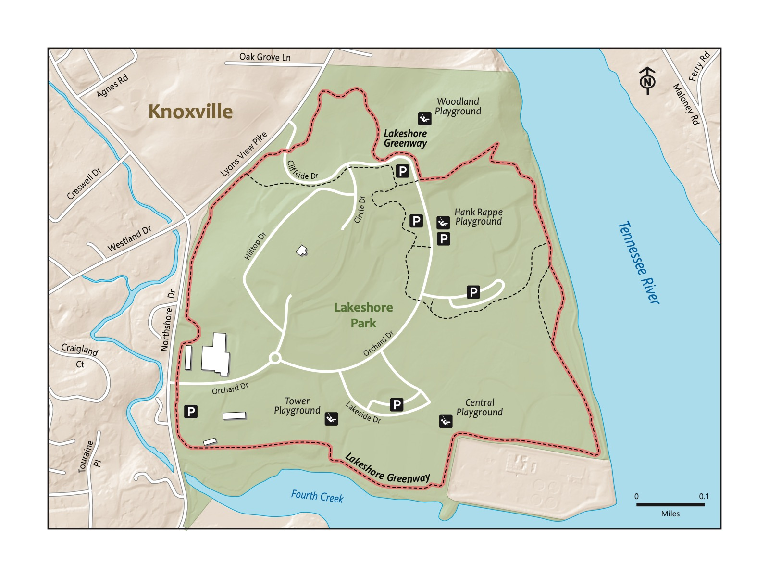

### Directions to the Trailhead

Trailhead Address: Lakeshore Park, 6014 Lyons View Pike, Knoxville, TN 37919

Trailhead GPS Coordinates: 35.92389, -83.990

The address above navigates to the park’s main entrance. Our hike starts at a large parking area near the center of the park. To find it, entering Lakeshore from Lyons View Pike, turn onto Cliffside Dr. and park in the large parking area on the right, immediately past Circle Dr. Start on the greenway near the parking lot on the same side of the road on which you are parked. Of course, you can park elsewhere nearby or in any parking area at Lakeshore.

### Trail Description

| Distance from Start | Description |
| --- | --- |
| 0.0 | Cross Orchard Drive, heading clockwise on the paved greenway. Note the greenway on the left, which immediately heads toward the Huie Woodland Playground. |
| 0.05 | Bench and overlook to the Smokies. Can you spy Clingman’s Dome? Note that Hank Rappé playground is immediately below the greenway (to your right). |
| 0.15 | Short, steep descent! |
| 0.4 | Optional boardwalk section (recommended!). Check out the viewing platform overlooking the Tennessee River around 200 feet ahead on the left. |
| 0.5 | Boardwalk and the primary greenway reconnect. |
| 0.9 | Central Playground on the right. |
| 1.2 | Tower Playground on the right. |
| 1.5 | Ascent (followed by a little hill back down) begins. |
| 2.2 | Traihead. |

#### Appalachian Trail

Surprisingly, the crest of the Smokies (and the Appalachian Trail) are visible from this park. The Appalachian Trail is more than 2,100 miles long, beginning at Springer Mountain, Georgia, and ending at Mount Katahdin, in Maine. The longest section without a road crossing is in the Smokies – from Fontana Dam to Newfound Gap.  
:::

### Nearby

|  |
| --- |
| Photo credit to Katie and Joshua Rosenberg |

Photo credit to Katie and Joshua Rosenberg

* **Enjoy one or more of the many playgrounds!** There are four awesome playgrounds at Lakeshore: Hank Rappé (universal playground with a bit of everything), Huie Woodland (nature-themed), Tower (lots of climbing opportunities, best for kids age 5 and older), and Central (best suited for ages 5 and older, and with workout equipment nearby for adults).
* **Bring a picnic!** Lakeshore seems made for picnics. Enjoy one on a grassy area or one numerous seating areas near the Hank Rappé, Tower, and Central playgrounds.

# Trail 4: High Ground Park

### Overview

This is one of the closest hikes to the city center of Knoxville, and it’s stroller-friendly! This short but sweet hike is perfect as a real but accessible outing for toddlers and little kids. The red chairs at the top are a fun stopping point. The deep woods are pretty and offer something new in each season. This could be a great first hike for toddlers – it was one of the first for our little one, and made us feel like we could start venturing to other regional hiking destinations.

|  |
| --- |
| Photo credit to Katie and Joshua Rosenberg |

Photo credit to Katie and Joshua Rosenberg

### Key Characteristics

| **Characteristic** | **Details** |
| --- | --- |
| Time Estimate | 0.5 hours - 1 hour |
| Trail Distance (Miles) | 0.7 |
| Elevation Change | Gentle |
| Pets | Allowed on leash |
| Parking Pass/Entrance Fee | Not Required |
| Restroom(s) | No |
| Best Ages |  |
| Strollers and Wheelchairs |  |

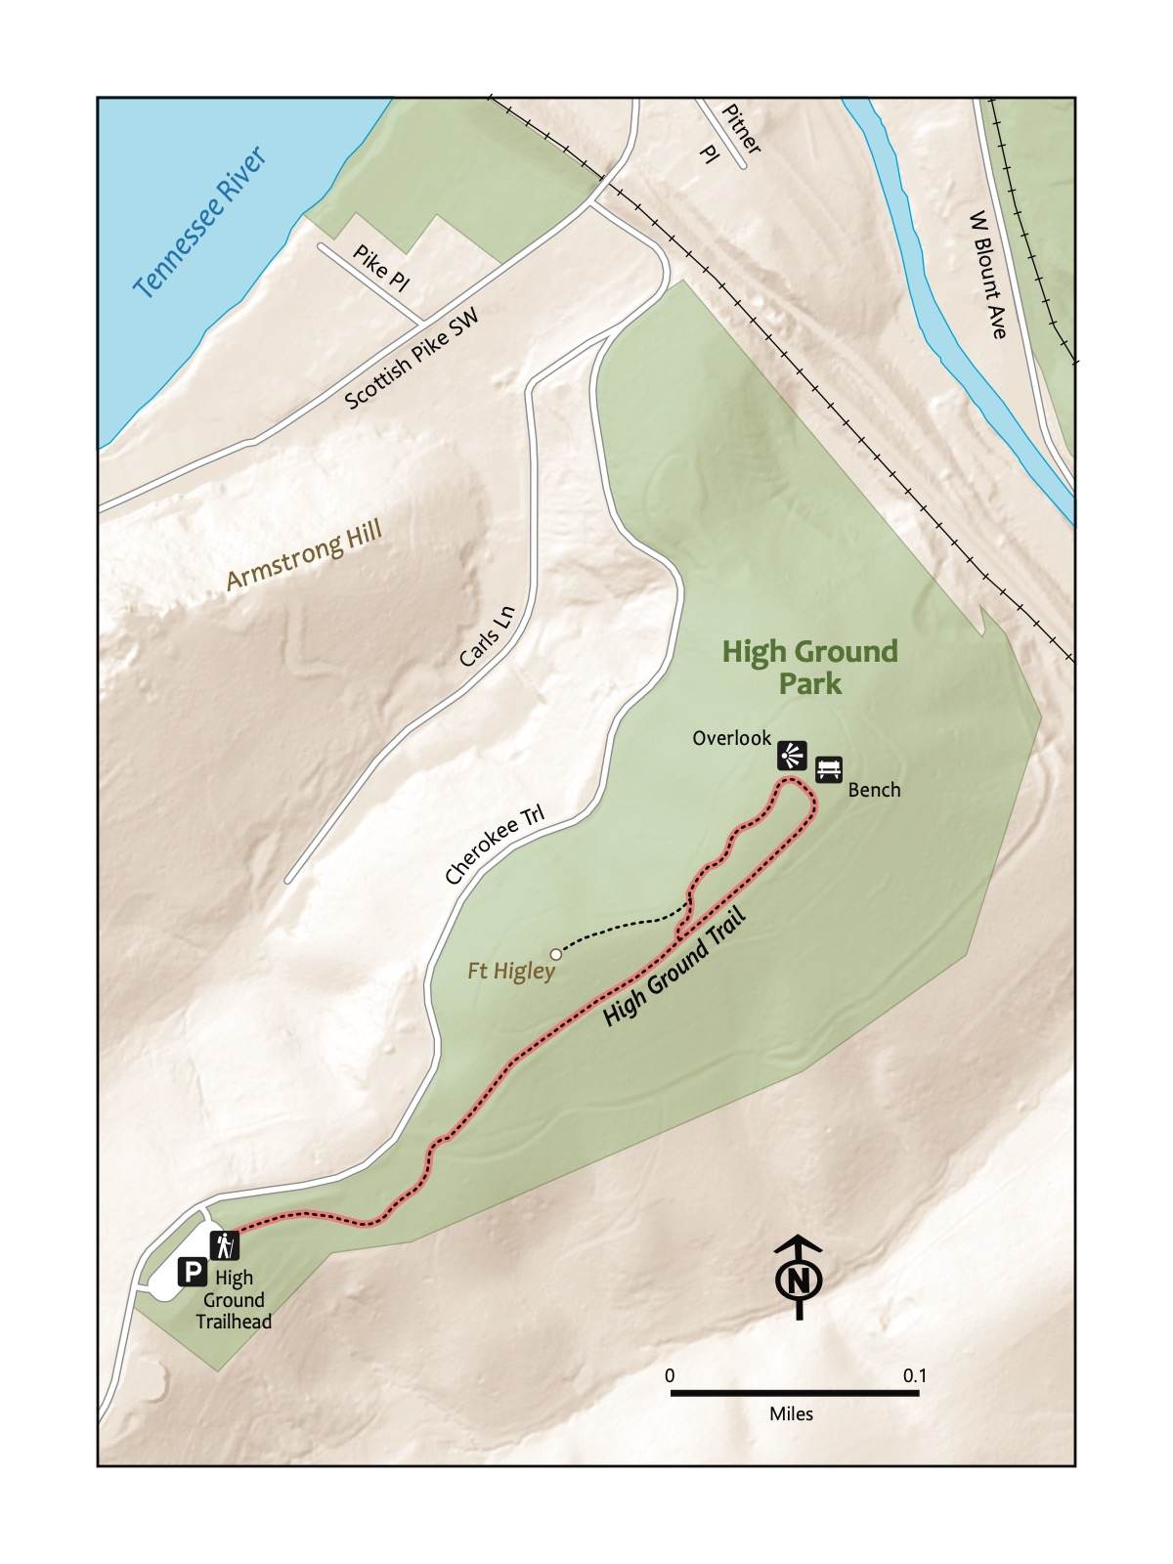

### Directions to the Trailhead

Trailhead Address: High Ground Park, 1000 Cherokee Trail, Knoxville, TN 37920

Trailhead GPS Coordinates: 35.93824, -83.9258

The trail begins from the parking lot at the above address; look for the paved path near the back of the parking lot. You can’t miss it!

|  |  |
| --- | --- |
|  | **Earthworks**  Structures formed from shaping rocks and soil, often as part of forts around Knoxville constructed during the Civil War. Surprisingly long-standing. The earthworks here and at the nearby Fort Dickerson include ramparts – small hills or banks that served as defensive walls. |

### Trail Description

| Distance from Start | Description |
| --- | --- |
| 0 | Start off on the trail with a gentle descent. |
| 0.1 | Enter the wooded part of the hike and begin a gentle climb. |
| 0.35 | Red chairs and the large open area. Head toward the mowed grassy section. |
| 0.4 | Look for a spur trail that heads to the site of the Fort Higley earthworks, constructed during the Civil War by Union forces. |
| 0.7 | Traihead. |

### Nearby

* ****Stop by a fun food hall before or after!**** The nearby Kern’s Food Hall (2201 Kerns Rising Way, Knoxville, TN 37920) has a good range of options and an outdoor play area for kids to romp around.
* ****For more outdoor fun, hike the nearby River Bluff Wildlife area.**** The nearby River Bluff Wildlife Area is an interesting counterbalance to the ease of High Ground Park - ****it features a short but rustic hike to a pretty overlook of the city.**** Visit Knoxville’s website (<https://www.visitknoxville.com/>) has more information and a nice map.

# Trail 5: UT Arboretum

### Overview

This is a gem of a hike that is off the radar for many in Knoxville, as it is tucked away in nearby Oak Ridge. Start your hike at a trailhead that offers many hiking options. We recommend walking up the paved path past botanical specimens, including uniuque conifers! Circle around park facilities past a pretty field and forests. Upon returning to the start, there are other trails to the different ecological zones represented in an area that is worth a visit; we like the trails near the marshy area with the clear creek, perfect for splashing in warm weather. Suitable for kids of all ages.

|  |
| --- |
| Photo credit to Katie and Joshua Rosenberg |

Photo credit to Katie and Joshua Rosenberg

### Key Characteristics %ADD STROLLER ACCESS%

| **Characteristic** | **Details** |
| --- | --- |
| Time Estimate | 0.5 hours - 1 hour |
| Trail Distance (Miles) | 0.9 |
| Elevation Change | Gentle |
| Pets | Not Allowed |
| Parking Pass/Entrance Fee | Not Required |
| Restroom(s) | No |
| Best Ages |  |
| Strollers and Wheelchairs |  |

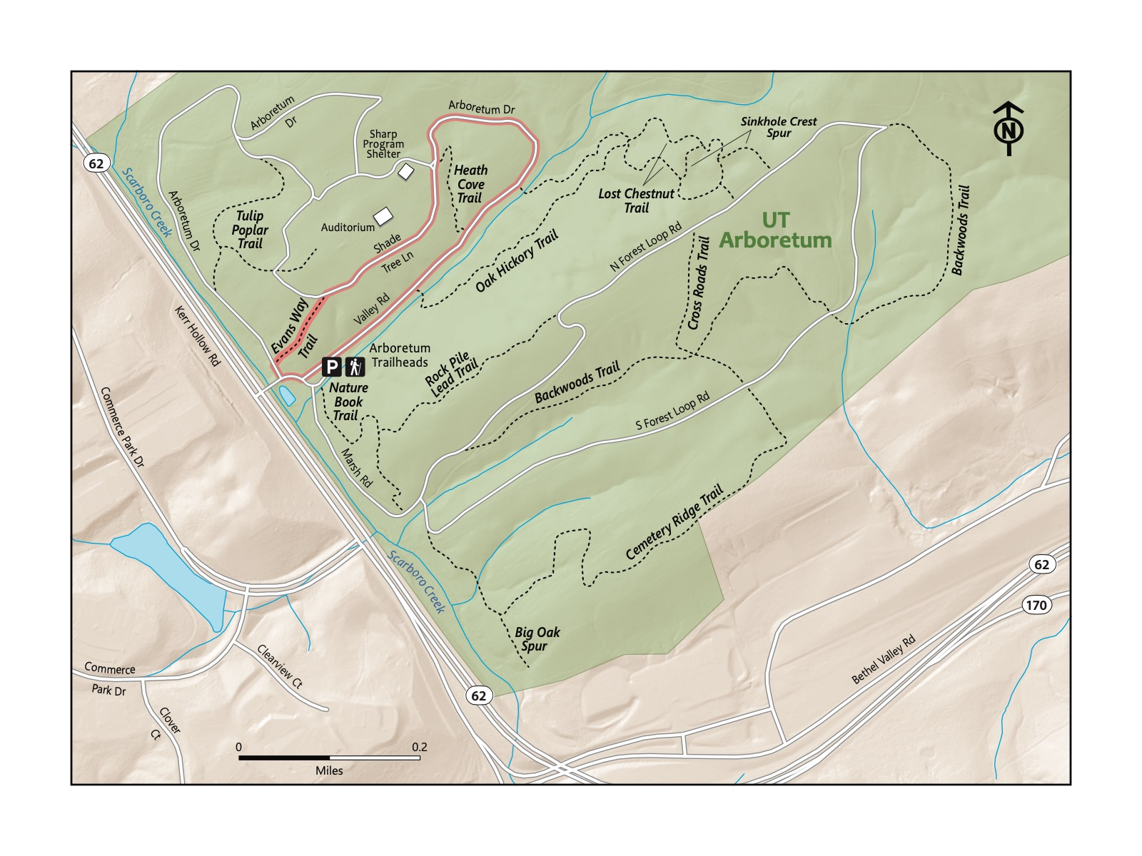

### Directions to the Trailhead

Trailhead Address: University of Tennessee Arboretum, 901 S Illinois Ave, Oak Ridge, TN 37830

Trailhead GPS Coordinates: 35.99392, -84.21988

The trailhead is easy to find with the above address. Park in the large parking lot for the University of Tennessee Arboretum, look for the road connected to it, and head straight, away from the parking area. The small stop sign that says “Authorized Vehicles Only” is at the start of this hike.

### Trail Description

| Distance from Start | Description |
| --- | --- |
| 0.0 | Walk along the paved road. |
| 0.1 | Start of the Oak-Hickory Trail on the right. |
| 0.2 | Start of the Heath Cove Trail on the left. This is a shortcut if you’re looking for one! |
| 0.3 | Wind around, still on the road. |
| 0.5 | Shelter on the right. |
| 0.6 | Auditorium on the right. |
| 0.7 | Leave the paved road for a short dirt path called Evans Way Trail. Alternatively, turn around and head back on the paved path. |
| 0.9 | Traihead. |

### Nearby

* **Explore some of the many other trails nearby.** The trail we featured meanders through a very small section of a large, diverse park. The Nature Book Trail is a great trail to add on to your hike. There are many others; check out the map at the UT Arboretum website (<https://utarboretum.tennessee.edu/>) to learn more.
* **Bring the balance bikes and kids’ bikes and stop by Haw Ridge and its kids’ pump track.** Nearby Haw Ridge Park features the Dirtlab Mountain Bike Skill Park, a great spot for kids riding balance bikes and pedal bikes to hone their skills and build confidence!

# Trail 6: Knox-Blount Greenway

### Overview

Another hike that is very close to Knoxville’s city center, the Knox-Blount Greenway, is a fun, easier outing for little walkers, bikers, and for parents pushing little ones in strollers. Paved throughout, this trail offers a glimpse of the surprising beauty of the Tennessee River so close to the city. Our description features a route that heads to the north, toward the city, and then back to the trail from the research park further south, before returning to the start. Look for blue herons and other birds along the side of the river; you might see a Bald Eagle! While beautiful, there is limited shade here, so factor the weather in before setting out to this destination! This will be a fun hike for a gaggle of kids looking to toddle or run wild!

|  |
| --- |
| Photo credit to Katie and Joshua Rosenberg |

Photo credit to Katie and Joshua Rosenberg

### Key Characteristics

| **Characteristic** | **Details** |
| --- | --- |
| Time Estimate | 45 minutes - 1.5 hours |
| Trail Distance (Miles) | 2.3 |
| Elevation Change | Gentle |
| Pets | Allowed on leash |
| Parking Pass/Entrance Fee | Not Required |
| Restroom(s) | No |
| Best Ages |  |
| Strollers and Wheelchairs |  |

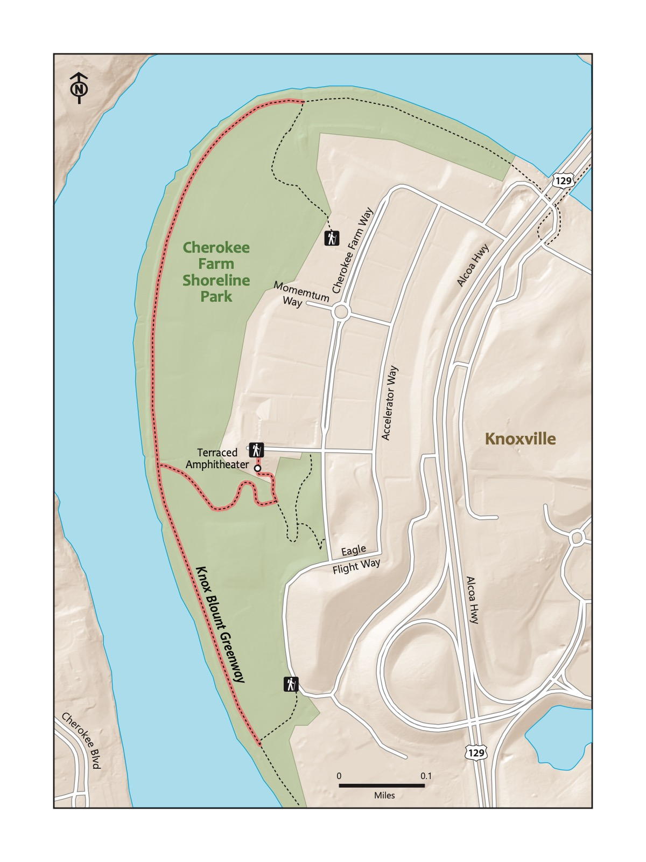

### Directions to the Trailhead %THE ABOVE PICTURE IS OF LAKESHORE PARK, BUT SHOULD BE KNOX-BLOUNT GREENWAY%

Trailhead Address: University of Tennessee Research Park at Cherokee Farm, 2641 Osprey Vista Way, Knoxville, TN 37920

Trailhead GPS Coordinates: 35.94191, -83.95270

Park in the lot at the above address. If helpful, the building next to the lot is the IAM Electron Microscopy Facility. The start of the trail is at the top of a terraced amphitheater—conveniently, one that’s easy to walk down.

### Trail Description

| Distance from Start | Description |
| --- | --- |
| 0.0 | Walk down the terraced amphitheater. |
| 0.1 | Begin to descend down a gradual hill. |
| 0.3 | Reach the river and the Knox-Blount Greenway trail proper. Our route turns right, but you can explore in either direction! |
| 0.35 | Follow the greenway along the river. The meadows to the right are usually mowed; kids may like to cruise through them! |
| 0.8 | Our preferred route turns around at the intersection of the greenway and a spur trail. Of course, you can continue further if you like. Head back the other direction |
| 1.3 | Pass the trail from the amphitheater you took earlier, continuing along the river. |
| 1.65 | Turn around at the intersection of another spur trail. |
| 2.0 | Meet back up with the trail to the amphitheater. |
| 2.3 | Traihead. |

### Nearby

* **Take time to visit the UT Gardens.** The nearby UT Gardens (2621 Morgan Circle, Knoxville, TN 37996) is a great spot for a meander through beautiful gardens. Be sure to check out the Children’s Garden featuring grassy mounds and ample play structures!
* **Bike the greenways!** While we featured the Knox-Blount Greenway as a hike, it’s also a fun bike ride for young bikers.

# Trail 7: Sequoyah Park

### Overview

This is another gem among Knoxville city parks, nestled in the heart of the the city in a neighborhood. The trail starts at a large parking area near the restroom building and walks towards the river. It follows the river past open fields, trees, and bushes which playfully beckon for kids not to explore! The trail cuts up toward the greenway and hikes past Indian burial mounds and the historic homes along the path before returning to the start. In mild weather, it is a fantastic spot to hang up a hammock, fish, have a picnic, or toss a frisbee or a football. This outing is ideal for kids of all walking ages, and alternate ways to access the greenway make it easy to create a shorter loop.

|  |
| --- |
| Photo credit to Katie and Joshua Rosenberg |

Photo credit to Katie and Joshua Rosenberg

### Key Characteristics

| **Characteristic** | **Details** |
| --- | --- |
| Time Estimate | 1 hour - 2 hours |
| Trail Distance (Miles) | 2.1 |
| Elevation Change | Flat |
| Pets | Allowed on leash |
| Parking Pass/Entrance Fee | Not Required |
| Restroom(s) | Yes |
| Best Ages |  |
| Strollers and Wheelchairs |  |

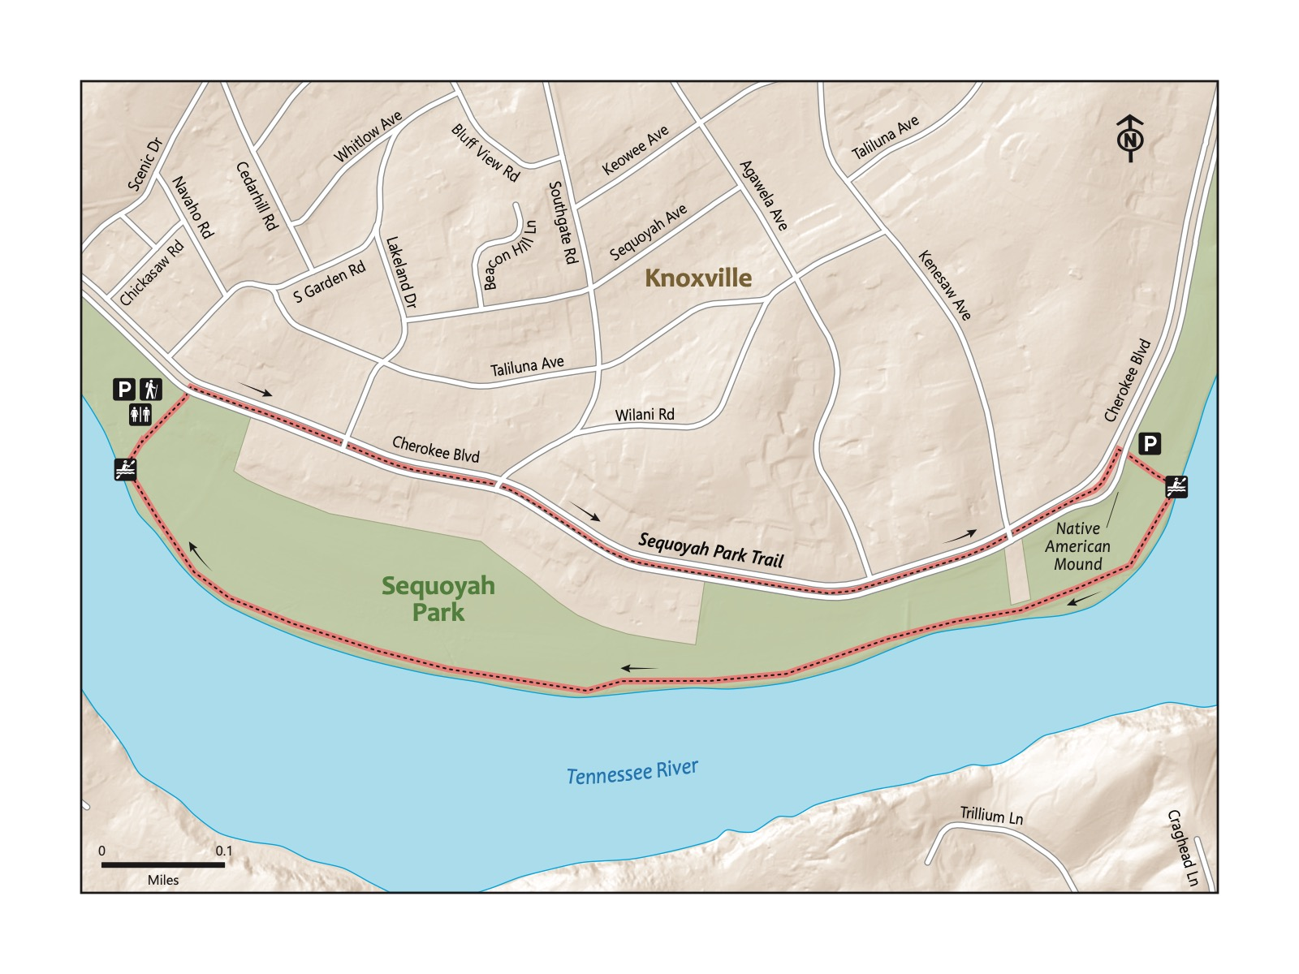

### Directions to the Trailhead

Trailhead Address: Sequoyah Park Restrooms, W2HG+M9, Knoxville, TN 37919

Trailhead GPS Coordinates: 35.92932, -83.97398

The above address takes you to the parking area next to restrooms that serve as a landmark for this sprawling park. Please note that the address uses a “Plus” code that only works with Google Maps because the restrooms and trailhead don’t have an assigned address. %EXPLAIN PLUS CODE%

### Trail Description

| Distance from Start | Description |
| --- | --- |
| 0.0 | Walk southwest (toward the large, open part of the park) along the river. |
| 0.1 | Kayak and canoe put in spot on the right. |
| 0.25 | Enter a wooded section. |
| 0.4 | Bench. |
| 0.65 | Distinctive, dome-shaded trees that kids can crawl into, between, and through. |
| 0.9 | Small rocky hill to walk over (you can walk around it on the greenway, but kids may enjoy scrambling up it). |
| 1.1 | Boat launch. Head up beside or through the parking lot to Sequoyah Greenway in the center of Cherokee Blvd. Turn left onto the greenway. |
| 1.2 | Indian burial mound. Note the historical marker. Walk along past the homes on both sides of the greenway. |
| 2.05 | Traihead. |

|  |
| --- |
| Photo credit to Katie and Joshua Rosenberg |

Photo credit to Katie and Joshua Rosenberg

### Nearby

* **Grab a coffee, baked good, or breakfast!** Nearby Treetop Coffee Shop (1206 Kenesaw Ave, Knoxville, TN 37919) and The Plaid Apron restaurant (1210 Kenesaw Ave, Knoxville, TN 37919) next door are great places to stop by. Check their hours of operation before visiting!
* **Explore a bit more of the neighborhood!** Nearby Whitlow Park (4228 Whitlow Ave SW, Knoxville, TN 37919) features a small but fun playground, nice tennis courts, and a basketball court.

# Trail 8: Ijams Crag

### Overview

This trail is a nice introduction to the area of Ijams that is centered around Mead’s Quarry, which Ijams refers to as the Quarryside area. The hike begins at the quarry and winds up a smooth then rocky trail. The overlook is for Ijams Crag, a popular outdoor rock climbing area. We love having a snack at the shade of the pine trees at the overlook. After winding back to the start, be sure to explore one of the two excellent nature play areas nearby or take a side trail back to extend the trip. This area offers something for all ages, but the hike itself is best suited to young hikers who are able navigate steeper, rocky terrain. Younger hikers will need assistance.

|  |
| --- |
| Photo credit to Katie and Joshua Rosenberg |

Photo credit to Katie and Joshua Rosenberg

### Key Characteristics

| **Characteristic** | **Details** |
| --- | --- |
| Time Estimate | 45 minutes - 1.5 hours |
| Trail Distance (Miles) | 1.5 |
| Elevation Change | Moderate |
| Pets | Allowed on leash |
| Parking Pass/Entrance Fee | Not Required |
| Restroom(s) | Yes |
| Best Ages |  |
| Strollers and Wheelchairs |  |

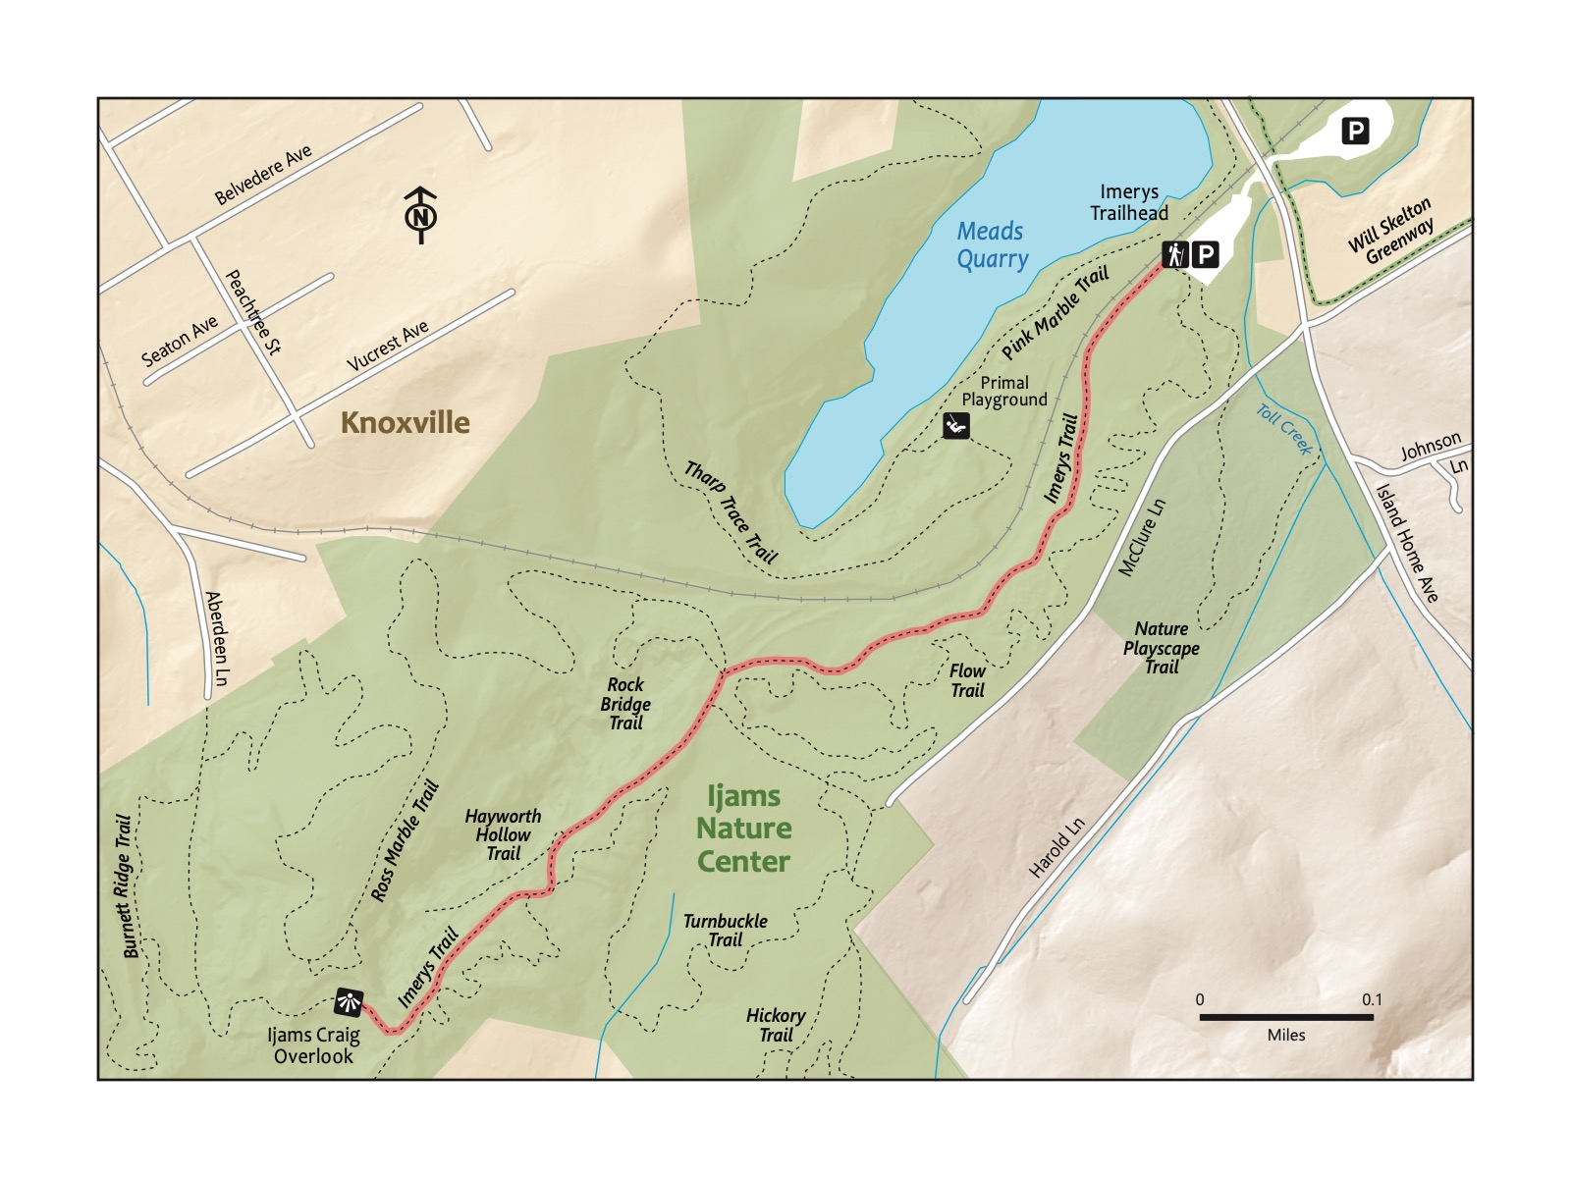

### Directions to the Trailhead

Trailhead Address: Meads Quarry, 3526 Island Home Ave, Knoxville, TN 37920

Trailhead GPS Coordinates: 35.95174, -83.86587

Park in the parking lot for Meads Quarry using the above address. The trail begins alongside the disused railroad tracks; look for a sign for Imery’s Trail.

### Trail Description

| Distance from Start | Description |
| --- | --- |
| 0.0 | Start on Imery’s trail, heading away from the parking lot. |
| 0.15 | Gradually, then more steeply, begin to ascend. |
| 0.30 | Trail levels out at an intersection between Imery’s Trail, Rock Bridge Trail, and Gravel Road Trail. |
| 0.5 | Rocky and steep. |
| 0.75 | Reach the overlook to Ijams Quarry. Rest up, and then turn around to head back, or continue farther along on Imery’s! |
| 1.50 | Traihead. |

### Nearby

* **Make sure to stop by the Ijams Visitor Center for a unique gift shop and a small collection of local river-based animals!** Check out the Ijams River and Tower loop for an introduction to this other area of the Ijams Nature Center.
* **Play at the Ijams Nature Playscape.** This is an amazing part of Ijams, worthy of a visit on its own. Tucked away a bit on the side of the parking area at Mead’s Quarry. It’s a favorite for kids, with a treehouse, tightrope, stumps for jumping, and, yes, a mud pit!
* **Check out the Ijams Primal playground.** Also nearby, smaller than the Nature Playground, but packed with features for climbing and jumping for kids able to climb and explore with little adult assistance.

# Trail 9: William Hastie

### Overview

You’ll be surrounded by trees galore at William Hastie! The start features a beginner’s mountain bike loop on a smooth path. Though short, this hike takes you by many spur trails; consider this a gentle introduction to a trail system close to but more rustic than Ijams. Good for all toddling and walking kids and their families.

|  |
| --- |
| Photo credit to Katie and Joshua Rosenberg |

Photo credit to Katie and Joshua Rosenberg

### Key Characteristics

| **Characteristic** | **Details** |
| --- | --- |
| Time Estimate | 0.5 hours - 1 hour |
| Trail Distance (Miles) | 1.3 |
| Elevation Change | Flat |
| Pets | Allowed on leash |
| Parking Pass/Entrance Fee | Not Required |
| Restroom(s) | No |
| Best Ages |  |
| Strollers and Wheelchairs |  |

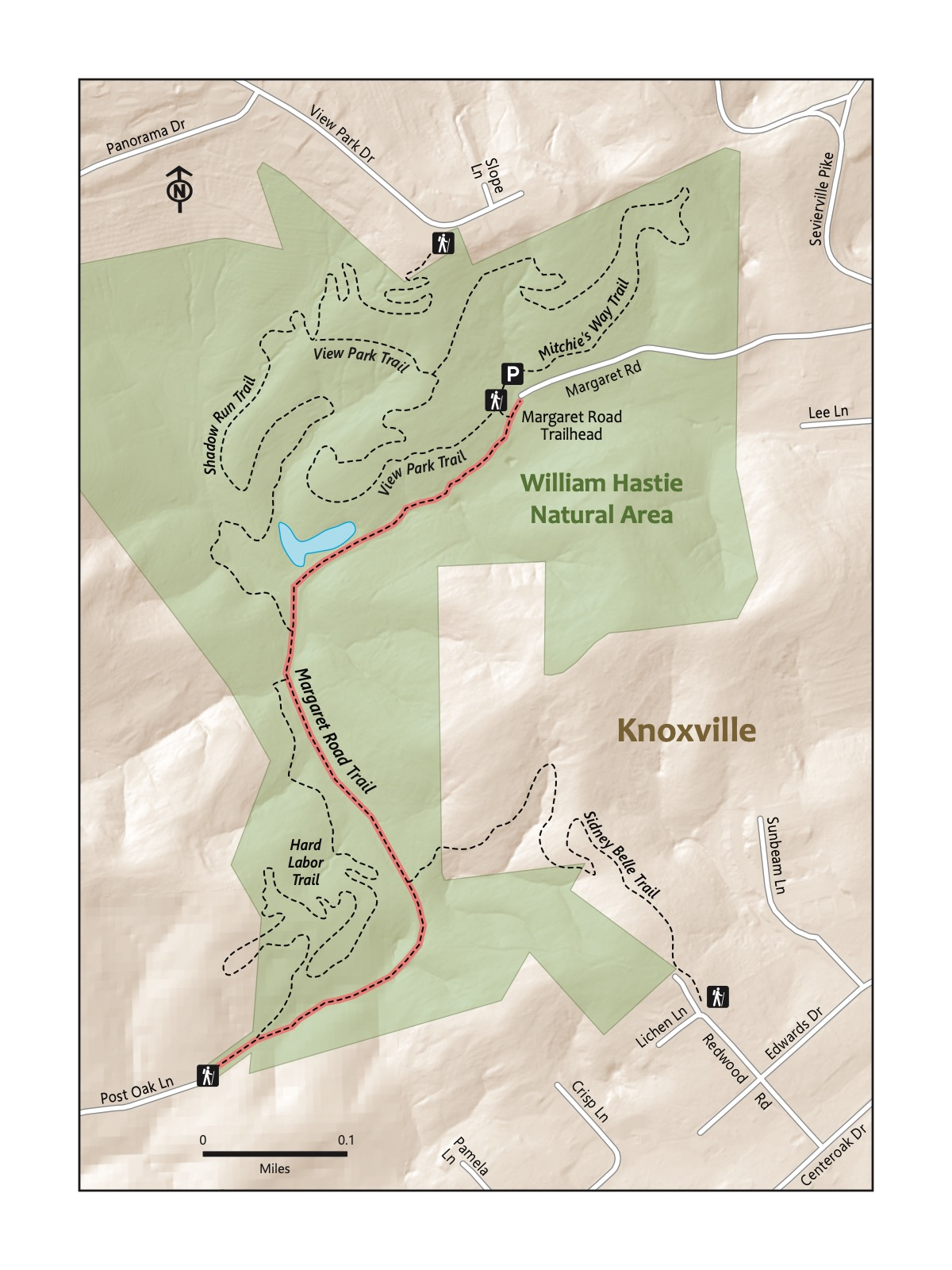

### Directions to the Trailhead

Trailhead Address: William Hastie Natural Area, 1302 Margaret Rd, Knoxville, TN 37920

Trailhead GPS Coordinates: 35.93464, -83.87455

The above address will direct you to a large, rarely-busy parking lot and a nice trailhead with a picnic area. Several trails start from this trailhead. Look for a sign for the Margaret Road Trail.

### Trail Description

| Distance from Start | Description |
| --- | --- |
| 0.0 | Start on the Margaret Road Trail. |
| 0.2 | Small pond on the right. Look for turtles! |
| 0.25 | Shadow Run Trail on the right. |
| 0.65 | Reach the Post Oak Ln. Trailhead and turn around. |
| 1.30 | Traihead. |

### Nearby

* **Bring bike and enjoy the kids’ loop.** The “green” mountain biking trail, Springarn, is a great spot for kids to begin to learn to ride on trails. It’s only 0.6 miles and is a nice complement to this hike.
* **Explore some of the many other trails while you’re there.** William Hastie Natural Area features many other trails of varying difficulty. Consider taking Mitchie’s Way from near the parking area—and then looping back to Margaret Road and the start on the trail of your choice.

# Trail 10: Sharp’s Ridge

### Overview

This hike is just north of downtown, making it a great stop before grabbing a bite to eat at a nearby restaurant or heading downtown. Wind up from the trailhead on a smooth path through the pretty forest. When we think of this trail, we think of little ones toddling or running ahead around the bends in the trail, just far enough to be out of sight for a little bit until we catch up! Once you connect to the road, consider walking up to an overlook with lovely view of the Smokies. Best for older kids or younger kids who are carried in a carrier or backpack.

|  |
| --- |
| Photo credit to Katie and Joshua Rosenberg |

Photo credit to Katie and Joshua Rosenberg

### Key Characteristics

| **Characteristic** | **Details** |
| --- | --- |
| Time Estimate | 1.5 hours - 2.5 hours |
| Trail Distance (Miles) | 2.3 |
| Elevation Change | Moderate |
| Pets | Allowed on leash |
| Parking Pass/Entrance Fee | Not Required |
| Restroom(s) | No |
| Best Ages |  |
| Strollers and Wheelchairs |  |

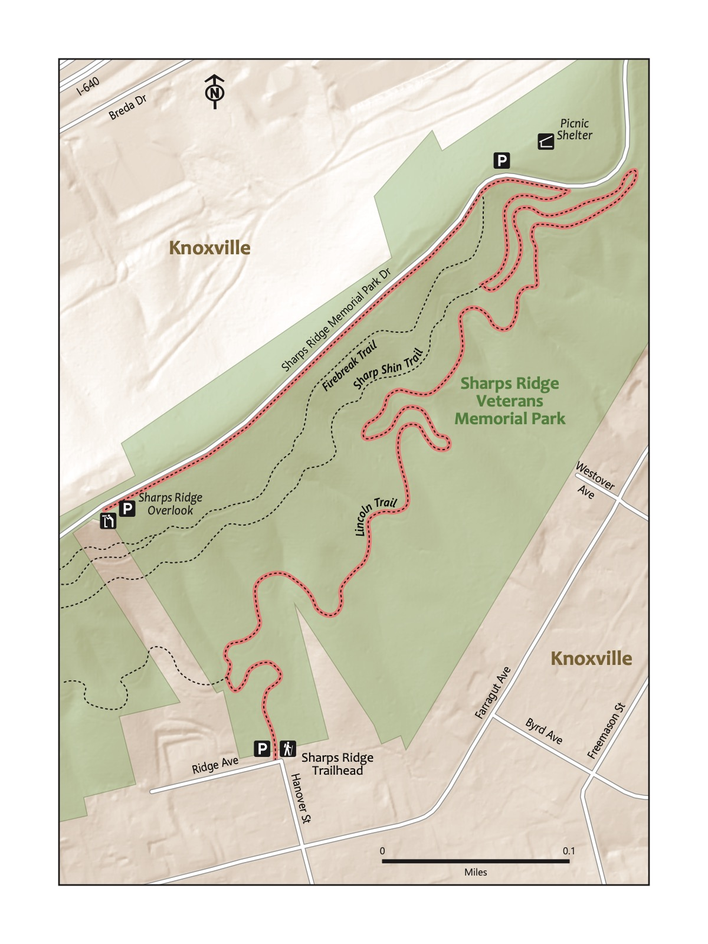

### Directions to the Trailhead

Trailhead Address: Sharps Ridge Trailhead, 599-501 Ridge Ave, Knoxville, TN 37917 Trailhead GPS Coordinates: 36.00344, -83.93787

Trailhead GPS Coordinates: 36.00344, -83.93787

The trailhead can be just a little tricky to find—partially because Google Maps has several trailheads with the same name! We once met friends at different Sharps Ridge Trailheads! Consider putting in the address (above) to find the trailhead, which is at the end of Hanover St. Park in one of the parking spots or the gravel area on the side of Ridge Ave.

|  |  |
| --- | --- |
|  | **Lichen**  There are three primary types of lichens: Foliose (leaf-like in appearance), Crustose (crusty looking), and Fruiticose (coral-like and bushy). They are abundant in the region and are great bioindicators of air quality! -Amanda Garner |

### Trail Description

| Distance from Start | Description |
| --- | --- |
| 0.0 | Start by walking through the Arbor, past the trail map of the Sharps Ridge area. You’re technically on the very short Hanover Access trail. |
| 0.1 | Turn right onto Lincoln Trail. Wind up through the deep woods and easy curves in the trail. |
| 0.8 | Turn right onto Sharp Shin. |
| 0.9 | Meet Sharps Ridge Memorial Park Drive. Turn left to walk along the side of the road toward the overlook, or, alternatively, head back to the start! |
| 1.15 | Overlook. See if you can spy the Sunsphere, Neyland Stadium, and the Smokies in the distance. Turn around to head back the way you came. |
| 1.4 | Turn right, back onto Sharp Shin. |
| 1.5 | Turn left onto Lincoln Trail. |
| 2.2 | Turn left onto the Hanover Access Trail. |
| 2.3 | Traihead. |

|  |
| --- |
| Photo credit to Katie and Joshua Rosenberg |

Photo credit to Katie and Joshua Rosenberg

### Nearby

* **Grab a bite to eat at a nearby restaurant.** Favorite nearby spots include the fantastic Wild Love Bakehouse (1625 N Central St, Knoxville, TN 37917), the quick, inexpensive, tasty Taqueria La Herradura (2625 N Broadway, Knoxville, TN 37917), and Hard Knox Pizza Central (2300 N Central St, Knoxville, TN 37917).
* **Hike further or on other trails to keep the adventures rolling.** Sharp’s Ridge includes many other trails. A favorite starts at a different nearby parking area, immediately behind the Cherry Creek Apartments (navigate to 3404 Dill St, Knoxville, TN 37917). We like the Lincoln Trail, which is also an accessible mountain bike trail.

# Trail 11: Norris Dam State Park

### Overview

If you’re looking for a trail that youngest walkers can succeed it, head north of Knoxville about 30 minutes and check out the Songbird trail at Norris Dam State Park. Further, it’s on a graded gravel path. Like the Knox-Blount Greenway along the Tennessee River. You may be surprised by the variety and quantity of wildlife you see along the scenic Clinch River, which this hike invites you to enjoy as you stroll. This is a relaxing trail for a family outing that might end with a drive over Norris Dam or a stop for a bite and a drink at the nearby Clinch River Brewery. On warmer days, you’ll enjoy cooler temps at this riverside trail due to its location in the valley near water. For toddlers who are no longer happy in a stroller or backpack carrier, this hike would be a fun and rewarding challenge!

|  |
| --- |
| Photo credit to Katie and Joshua Rosenberg |

Photo credit to Katie and Joshua Rosenberg

### Key Characteristics

| **Characteristic** | **Details** |
| --- | --- |
| Time Estimate | 1.5 hours - 2.5 hours |
| Trail Distance (Miles) | 2.3 |
| Elevation Change | Gentle |
| Pets | Allowed on leash |
| Parking Pass/Entrance Fee | Not Required |
| Restroom(s) | No |
| Best Ages |  |
| Strollers and Wheelchairs |  |

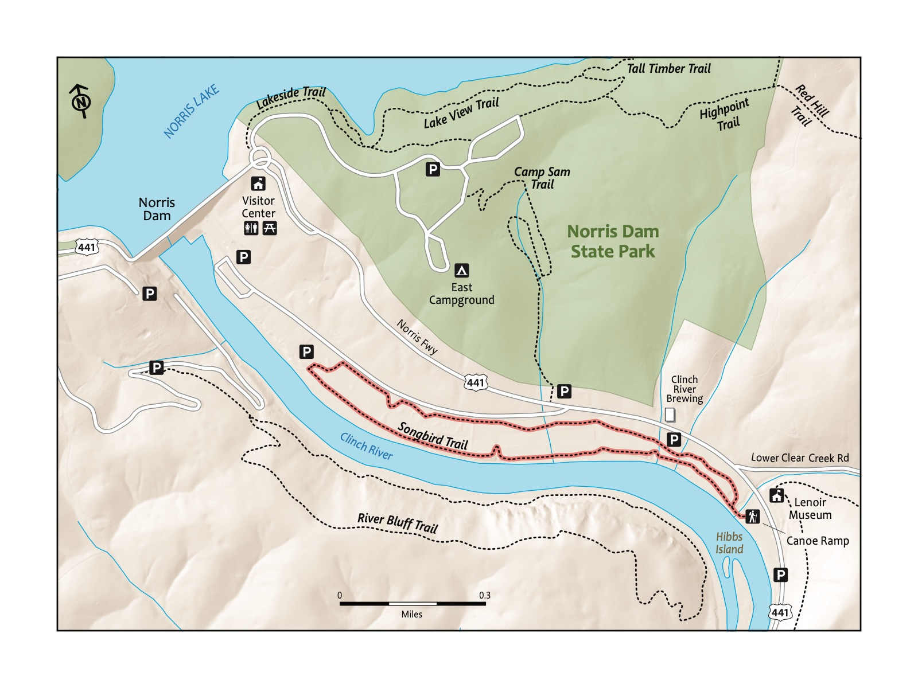

### Directions to the Trailhead

Trailhead Address: Canoe Ramp by the Songbird Loop, 6W6G+R7 Rocky Top, Tennessee

Trailhead GPS Coordinates: 36.21210, -84.07397

There are several possible trailheads. We chose to start this hike from a put in spot for kayaks and canoes. In Google Maps, you can search the above address. Please note it uses a “Plus code” instead of a street address, as the canoe ramp does not have an address. This is immediately off Norris Fwy. (Highway 441).

### Trail Description

| Distance from Start | Description |
| --- | --- |
| 0.0 | Cross a short bridge over Clear Creek. |
| 0.05 | Turn right (though, it is a loop and you may choose to go the other other way). |
| 0.3 | Cross a short bridge. |
| 1.0 | Turn left, toward the river, remaining on the same trail. |
| 1.05 | Follow the trail back along the river. |
| 2.3 | Trailhead. |

### Nearby

* **Grab a bite and a drink Clinch River Brewery.** Clinch River Brewing (2045 Norris Fwy, Norris, TN 37828) is not within the boundaries of the Norris Dam State Park—but it’s very close to the trailhead and is a fun place to stop for lunch or dinner before or after a hike.
* **Check out the Norris Dam, which has been in operation since the mid-1930s.** Stop at the TVA Norris Dam Visitor Center on the same side of the Clinch River as this hike—or drive across and back over the dam for an impressive, even otherworldly experience!

|  |
| --- |
| Photo credit to Katie and Joshua Rosenberg |

Photo credit to Katie and Joshua Rosenberg

# Trail 12: House Mountain State Natural Area

### Overview

This hike is not for the faint of heart, as the elevation gain is significant! If you have littles that need to be carried, we recommend waiting to tackle this hike (Katie carried our oldest in a baby carrier up this hike when he was a baby and will honestly tell you she doesn’t have fond memories of this hike). This one always challenges us! But, the flip side is that House Mountain offers a challenging hike to a rewarding overlook far nearer to Knoxville than those in the Cumberland Plateau or the Great Smoky Mountains National Park. The trail climbs up House Mountain from the west, reaching the West Overlook before heading down to complete the loop.

|  |
| --- |
| Photo credit to Hanhui Bao |

Photo credit to Hanhui Bao

### Key Characteristics

| **Characteristic** | **Details** |
| --- | --- |
| Time Estimate | 2.5 hours - 4.5 hours |
| Trail Distance (Miles) | 2.5 |
| Elevation Change | Steep |
| Pets | Allowed on leash |
| Parking Pass/Entrance Fee | Not Required |
| Restroom(s) | No |
| Best Ages |  |
| Strollers and Wheelchairs |  |

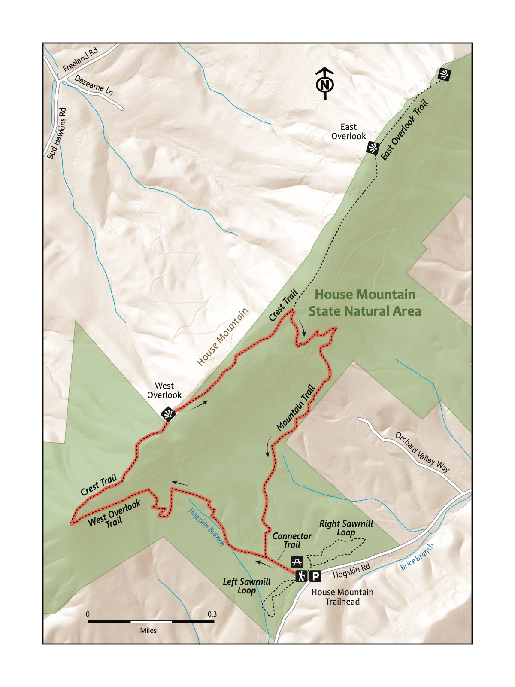

### Directions to the Trailhead

Trailhead Address: House Mountain Parking and Trailhead, 463P+WV Corryton, Tennessee

Trailhead GPS Coordinates: 36.10483, -83.76276

Park at the large parking area and look for the large covered picnic area. The Connector Trail near the picnic area tis where you’ll begin the hike.

|  |  |
| --- | --- |
|  | **Pine Trees (Family)**  A group of conifers (trees with needles typically attached in bundles, and seeds in cones that are typically very rigid) that is distinct from Hemlocks, Spruce, and Fir. |

### Trail Description

| Distance from Start | Description |
| --- | --- |
| 0.0 | Start on the Connector Trail. |
| 0.1 | Turn left onto the West Overlook Trail and begin your ascent. |
| 0.85 | Rocky prominence. The trail changes here to the Crest Trail and flattens. |
| 1.25 | Reach the West Overlook. Continue on the Crest Trail. Optionally, this is a suitable turn-around spot. |
| 1.6 | Intersection with the East Overlook Trail. Turn right. |
| 1.7 | Steep descent. |
| 2.0 | Trail levels out, and the descent becomes more gradual and winding. |
| 2.3 | Trailhead. |

### Nearby

* **Spend some time at Zoo Knoxville on the way home.** Zoo Knoxville (3500 Knoxville Zoo Dr, Knoxville, TN 37914) is accessible from I-40, on the way to House Mountain for those traveling from Knoxville or west of the city center, is a fantastic place to spend half a day (or longer)! It is one of our family’s favorite spots.

# Trail 13: Emory Falls at Frozen Head State Park

### Overview

Writing about this trail makes us smile. In many ways, it’s the perfect kid hike! It starts at a beautiful trailhead along a pretty creek in the deep woods. It gradually climbs before stopping at one of two scenic waterfall, DeBord Falls, and is a perfectly acceptable place to turn around with younger kids (we have many times!). It continues further to Emory Falls before returning on a gradual slope back to the trailhead. Stop at the playground you passed on the way to the trailhead beside the same creek; the water is usually shallow enough to be perfect for splashing and rock hopping. Please note, the trail is rocky, and your kids will likely need reminders to slow down!

|  |
| --- |
| Photo credit to Katie and Joshua Rosenberg |

Photo credit to Katie and Joshua Rosenberg

### Key Characteristics

| **Characteristic** | **Details** |
| --- | --- |
| Time Estimate | 2 hours - 3.5 hours |
| Trail Distance (Miles) | 2.4 |
| Elevation Change | Moderate |
| Pets | Allowed on leash |
| Parking Pass/Entrance Fee | Not Required |
| Restroom(s) | No restrooms at the trailhead parking, but you will pass restrooms on the right about three quarters of a mile before the trailhead parking area. |
| Best Ages |  |
| Strollers and Wheelchairs |  |

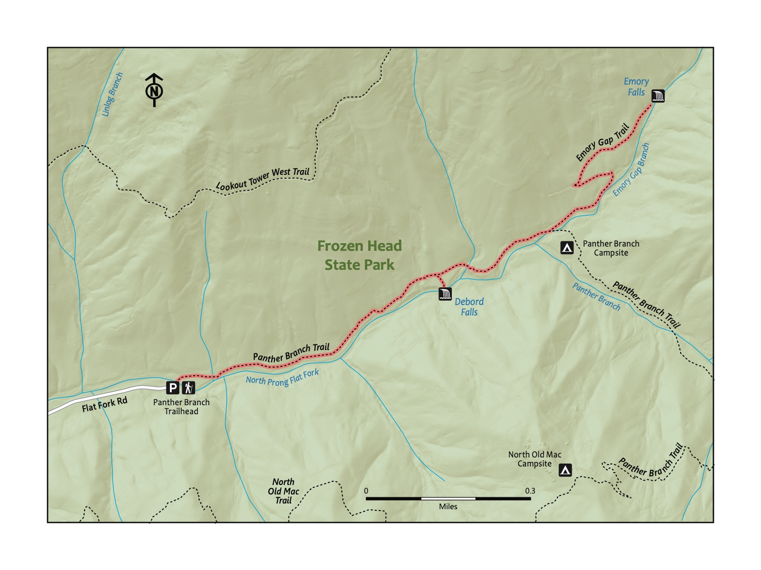

### Directions to the Trailhead

Trailhead Address: Emory Gap Trailhead, 4GP6+MV, Wartburg, TN 37887

Trailhead GPS Coordinates: 36.13658, -84.48785

Park at the Emory Gap Trailhead. Note that the above address uses a “Plus code” that will only work in Google Maps—because Emory Gap Trailhead does not have a street address.

|  |  |
| --- | --- |
|  | **Brushy Mountain State Penitentiary**  A closed prison near Frozen Head State Park is full of lore due to its remote location. Part of the inspiration for the Barkley Marathons (you’ll have to look it up if you haven’t heard of it). Now a site of a restaurant and distillery. |

### Trail Description

| Distance from Start | Description |
| --- | --- |
| 0.0 | Start by walking across the bridge at the trailhead. |
| 0.55 | DeBord Falls. Walk down the (steep!) stairs on the right to view the waterfall from below. Optional turnaround spot. |
| 0.9 | Trail switchbacks. |
| 1.1 | Steep and rocky section at the end to the viewing spot for Emory Falls. |
| 1.2 | After viewing the waterfall, head back to the start! |
| 2.4 | Trailhead. |

|  |
| --- |
| Photo credit to Katie and Joshua Rosenberg |

Photo credit to Katie and Joshua Rosenberg

### Nearby

* **Enjoy the playground!** There is a fun, shaded creekside playground 0.7 miles down the road from the trailhead. Most of the year, the creek is a perfect depth for safe splashing.
* **Check out the Flat Fork Story Book Trail.** Starting near the playground, this short trail is great for the littlest hikers.
* **Hike to the Frozen Head Mountain Summit.** A challenge for the biggest kid hikers and adults! This hike is around seven strenuous miles to and back from the Lookout Tower at the summit of Frozen Head Mountain, from which views of the Smokies far in the distance can be faintly visible on clear days.

# Trail 14: Point Trail at Obed Wild & Scenic River

### Overview

Just far enough to be off the radar of many in Knoxville, this trail has a bit of everything - fun bridge crossings, deep forest, waterfalls, and two pretty overlooks. It does not climb so much as to become tiresome, but it’s long enough to feel like a real adventure. There’s something about the Obed area that feels both wild and inviting. The only downside? It’s a little out-of-the-way; in some ways, this trail feels farther than some destinations in the Smokies. It’s worth it for a great family hike with kids of all ages. Though out of the way, there are a few fun things to do to extend the hike or to visit very nearby on the way home. Great for kids of all hiking ages, and not a bad hike on which to carry a little one.

|  |
| --- |
| Photo credit to Katie and Joshua Rosenberg |

Photo credit to Katie and Joshua Rosenberg

### Key Characteristics

| **Characteristic** | **Details** |
| --- | --- |
| Time Estimate | 2.5 hours - 4.5 hours |
| Trail Distance (Miles) | 3.6 |
| Elevation Change | Gentle |
| Pets | Allowed on leash |
| Parking Pass/Entrance Fee | Not Required |
| Restroom(s) | Yes |
| Best Ages |  |
| Strollers and Wheelchairs |  |

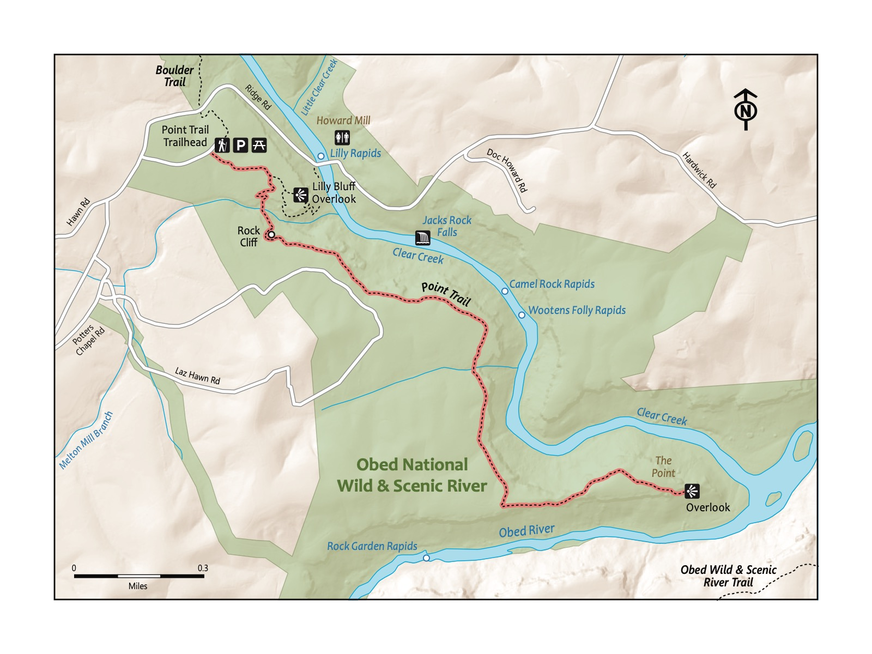

### Directions to the Trailhead

Trailhead Address: Lilly Bluff Trailhead, 1 Lilly Bluff Trail Head, Lancing, TN 37770

Trailhead GPS Coordinates: 36.10239, -84.72183

The above address should easily navigate you to the large parking area with a restroom. Look for the sign for the point trail.

### Trail Description

| Distance from Start | Description |
| --- | --- |
| 0.0 | Start on the Point Trail. |
| 0.15 | Side trail to the Lilly Bluff Overlook for Clear Creek (we recommend!). |
| 0.4 | Small bridge crossing. |
| 0.45 | Large boulders and a rock wall. The trail winds around the side and atop the back of the wall. |
| 0.5 | Trail flattens and winds along the side of a ridge. |
| 1 | Trail bends to the right. |
| 1.4 | Trail bends to the left. |
| 1.8 | Overlook of the juncture of Clear Creek and Obed River. There are many great spots to view the rivers! After a good rest, turn around and head back to the trailhead. |
| 3.6 | Trailhead. |

|  |
| --- |
| Photo credit to Katie and Joshua Rosenberg |

Photo credit to Katie and Joshua Rosenberg

|  |  |
| --- | --- |
|  | **Bigleaf Magnolia**  Has the largest simple leaf (a leaf with one piece) of any tree in North America. In the fall, the leaves look like pages of newspapers scattered on the ground! Common in the Cumberland Plateau (but not in the Smokies). |

### Nearby

* Hang out at Lilly Pad Hopyard Brewery, only open Saturdays and Sundays, 12-6 p.m. The Lilly Pad Hopyard Brewery (<https://www.lillypadhopyardbrewery.com>) is a surprising, fantastic, kid-friendly destination for food and drinks.
* Play around the bouldering area. The Trailhead features a nearby shaded area full of boulders. While we’ve often used this spot as a peaceful place to finish kiddo naps, older kids love trying to climb the boulders.

# Trail 15: Bandy Creek Trail at Scott State Forest

### Overview

A welcoming, gentle introduction to the Big South Fork. This hike pairs best with a stay at the campground or if you’re hiking the nearby Angel Falls Trail or the Fall Branch Falls trails. This happens to be the flattest trail in the book. While short, it’s almost entirely on a dirt path, making it a great hike for toddlers or little kids – or parents carrying babies in a carrier.

### Key Characteristics

| **Characteristic** | **Details** |
| --- | --- |
| Time Estimate | 45 minutes - 1 hour, 15 minutes %Just thought – might want to check if you do time like this, or if you abbreviate 1.25. Just want to keep it uniform% |
| Trail Distance (Miles) | 1.3 |
| Elevation Change | Flat |
| Pets | Allowed on leash |
| Parking Pass/Entrance Fee | Not Required |
| Restroom(s) | Yes |
| Best Ages |  |
| Strollers and Wheelchairs |  |

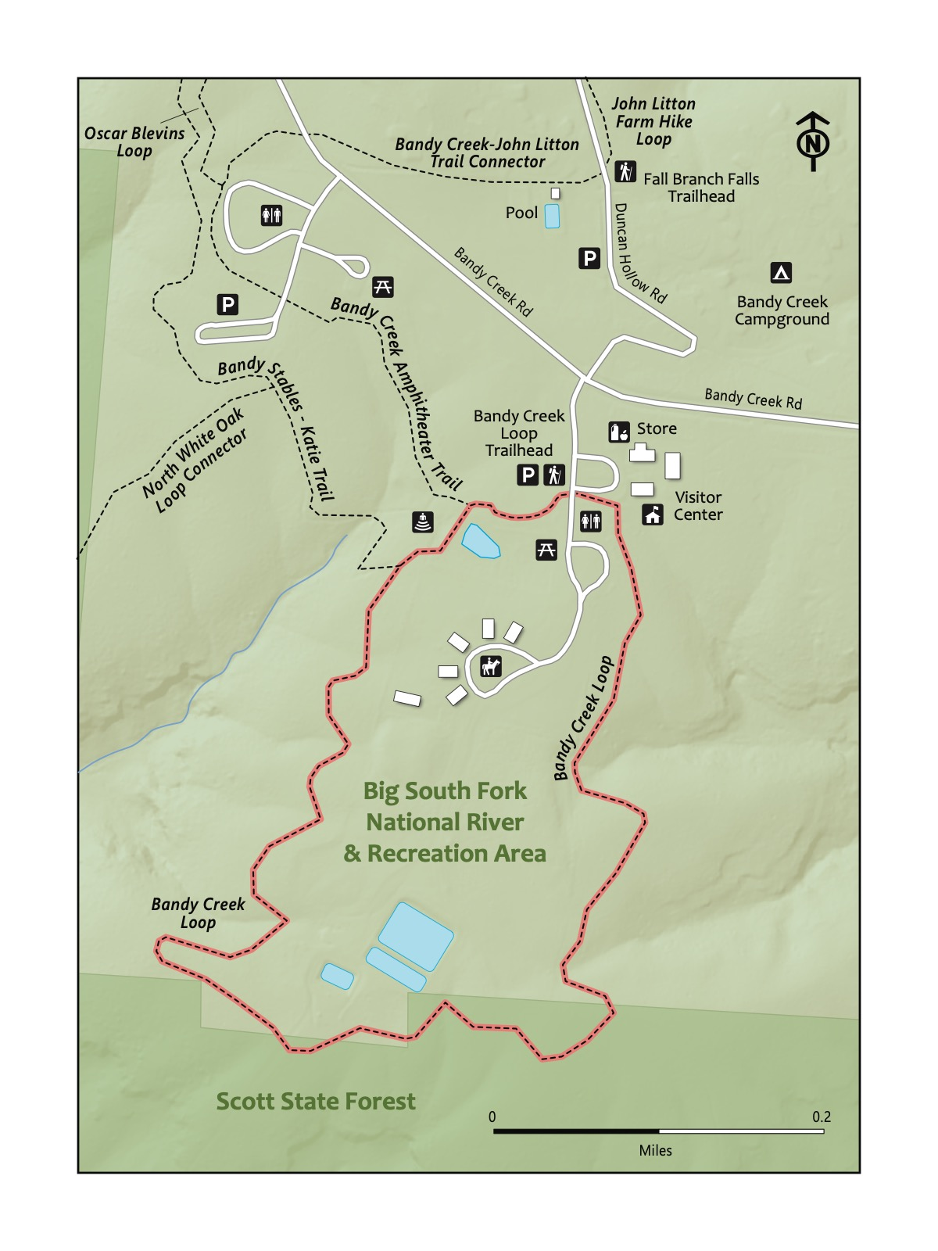

### Directions to the Trailhead

Trailhead Address: Bandy Creek Visitors Center, 151 Stable Rd, Oneida, TN 37841

Trailhead GPS Coordinates: 36.49062, -84.69777

The trailhead address will navigate you to the nearby Visitors Center (worth a visit when open (9:00 am - 5:00 pm year-round!). From the Visitors Center, look for the signs for the Bandy Creek Loop to begin the hike.

### Trail Description

| Distance from Start | Description |
| --- | --- |
| 0.0 | Start on the Bandy Loop Trail. Wind gradually toward the horse stables. |
| 0.15 | Pass the horse stables on the right. There’s an easy connector trail to them near the end of the loop. |
| 1.15 | Connector trail to the horse stables. |
| 1.3 | Return to the parking area and trailhead. |

### Nearby

* **Enjoy a visit at the horse stables.** Kids will likely love the nearby stables that often house many horses – most from guests at the campground who will ride the nearby horse-friendly trails. The nearby Bandy Creek Loop trail is also a good, short hike for young kiddos.
* **Camp at Bandy Creek.** This is a large, modern, scenic campground, very much worth a visit, though it is off-the-radar of many. You can almost always find a spot here—even on holiday weekends.
* **Hike the Fall Branch Falls or Angel Falls trails.** See those chapters for more details.

# Trail 16: Fall Branch Falls Trail at Big South Fork National River and Recreation Area

### Overview

This hike is a perfect counterbalance to the wonderful but far more familiar Great Smoky Mountains National Park. This hike, like the Big South Fork, is quieter and subtler than the Smokies. It features unique rock cliffs that are perfect for kids to take in and explore. The visitor center, horse stables (not to mention hundreds of miles of nearby trails), complement the hike. Because you can turn around at any point, this hike is great for kids of nearly any age. However, be aware of the ladders along the hike that can be a little tricky for the youngest kids to navigate!

|  |
| --- |
| Photo credit to VioletSkyAdventures |

Photo credit to VioletSkyAdventures

### Key Characteristics

| **Characteristic** | **Details** |
| --- | --- |
| Time Estimate | 2.5 hours - 4.5 hours |
| Trail Distance (Miles) | 3.7 |
| Elevation Change | Moderate |
| Pets | Allowed on leash |
| Parking Pass/Entrance Fee | Not Required |
| Restroom(s) | Yes |
| Best Ages |  |
| Strollers and Wheelchairs |  |

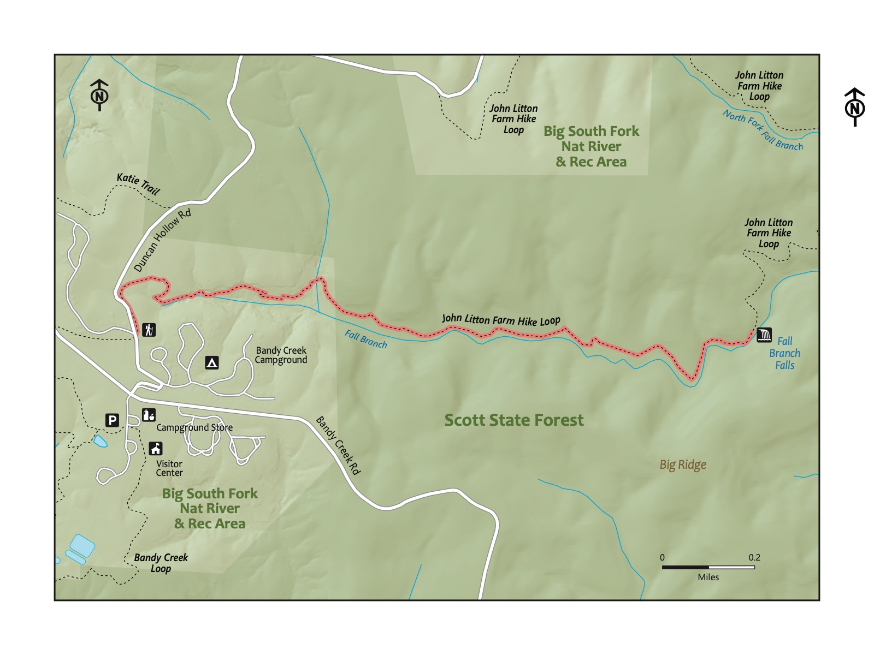

### Directions to the Trailhead

Trailhead Address: Bandy Creek Visitors Center, 151 Stable Rd, Oneida, TN 37841

Trailhead GPS Coordinates: 36.49062, -84.69777

From the Visitors Center, walk across Bandy Loop Road toward the campground. Find Duncan Hollow Road, and walk up it a short distance, passing the Bandy Creek Pool, which is another accessible parking area, on the left. The trailhead is immediately past the pool on the right side of Duncan Hollow Road.

### Trail Description

| Distance from Start | Description |
| --- | --- |
| 0.0 | Start on the Litten-Slaven Farm Loop Trail. |
| 0.2 | Begin to gradually descend into the Fall Branch creekbed. |
| 0.5 | Trail levels out. |
| 0.55 | Rocky section featuring a short ladder (to make it easier to navigate through the rocks). |
| 1.8 | Fall Branch Falls. A great spot for a break before turning around to return to the start. |
| 3.6 | Trailhead. |

### Nearby

* **Camp at Bandy Creek!** The Bandy Creek Campground is a gem - spacious sites, nice restrooms, and lots of cul-de-sacs for kids to endlessly play or bike. Consider a stay here as a launching point for this hike.
* **Stop by the visitor’s center.** A good place to learn more about the Big South Fork and to ask any questions or to seek the advice of park rangers.
* **Hike the nearby Bandy Creek or Angel Falls Trails.** Check out the Bandy Creek or Angel Falls Trails chapters. There are hundreds of hikes available to you, and any are well worth a hike (the Grand Gap Loop is a lengthy favorite!). Consider stopping the the visitor center to ask for recommendations and up-to-date information.

# Trail 17: Twin Arches Trail at the Big South Fork National River and Recreation Area

### Overview

This short hike leads to one of the most surprising geologic features in Tennessee! The Twin Arches, a 130-foot span and 100-foot height feature you can walk over, around, and through. The surrounding forest is not shabby, either. This is a fantastic and memorable family hike, with some challenges sprinkled in. First, this hike is the farthest (by driving distance) of any in this book. Second, there are some rocky sections that require some carefulness. Still, this is a must-see, and it’s near many features (and places to camp) to make a visit more accommodating. Good for families with children of any walking age.

|  |
| --- |
| Photo credit to Katie and Joshua Rosenberg |

Photo credit to Katie and Joshua Rosenberg

### Key Characteristics

| **Characteristic** | **Details** |
| --- | --- |
| Time Estimate | 1.5 hour - 2.5 hours |
| Trail Distance (Miles) | 1.2 |
| Elevation Change | Moderate |
| Pets | Allowed on leash |
| Parking Pass/Entrance Fee | Not Required |
| Restroom(s) | Yes |
| Best Ages |  |
| Strollers and Wheelchairs |  |

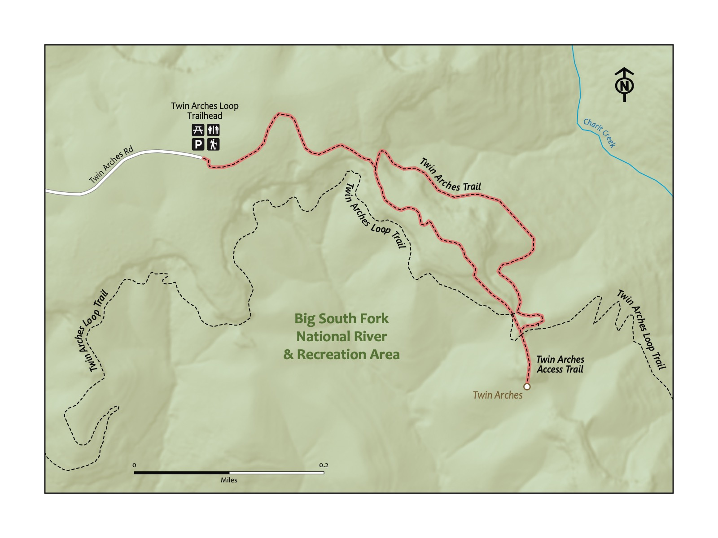

### Directions to the Trailhead

Trailhead Address: Twin Arches Trailhead, G7V5+Q7 Jamestown, Tennessee

Trailhead GPS Coordinates: 36.48797, -84.69744

The above address should easily navigate you to the large parking area with a restroom. Note that the above address uses a Google Maps “Plus code”, as the trailhead does not have a street address. This will only work in Google Maps. Park, and look for the sign for the Twin Arches trail near the back of the parking lot.

### Trail Description

| Distance from Start | Description |
| --- | --- |
| 0.0 | Start on the Twin Arches trail. |
| 0.25 | Intersection. Head right to complete the loop in a counterclockwise section. |
| 0.3 | Stairs. |
| 0.5 | Arrive at the base of the Twin Arches. Head straight - you won’t be able to miss them! |
| 0.6 | Twin Arches. Walk along the top of the arches, under them, and around them, and then head back toward the loop portion of the trail. |
| 0.7 | Turn right at the intersection to complete the loop. |
| 0.95 | Intersection. Turn right to return to the trailhead. |
| 1.20 | Trailhead. |

### Nearby

* **Camp or rent a cabin at Pickett State Park.** Pickett State Park (%ADDRESS OR WEBSITE%), a nice campground that also has both historic and modern cabins to rent, is close to this trail. It also features a great lake for kayaking, canoeing, or paddle boarding.
* **View the night sky.** Pickett State Park has a Silver-tier designation as an International Dark Sky Park. Even if you’re not strictly in the State Park, this is a great place to view stars and planets in the night sky.

# Trail 18: Angel Falls Trail at Big South Fork National River and Recreation Area

### Overview

Like a few of the other trails in or near the Cumberland Plateau, this is a spectacular hike that is sadly often overlooked. While this memorable trail is a little tricky to get to for a day hike, the view is awesome, rivaling the summits of the Smokies, with a different kind of vantage of the beautiful Big South Fork River. This trail is relatively flat and short, making it appropriate for families with young children. Consider camping at the nearby Bandy Creek campground, and consider this hike a day’s excursion from there.

|  |
| --- |
| Photo credit to Katie and Joshua Rosenberg |

Photo credit to Katie and Joshua Rosenberg

### Key Characteristics

| **Characteristic** | **Details** |
| --- | --- |
| Time Estimate | 1.5 hours - 2.5 hours |
| Trail Distance (Miles) | 2.8 |
| Elevation Change | Gentle |
| Pets | Allowed on leash |
| Parking Pass/Entrance Fee | Not Required |
| Restroom(s) | No |
| Best Ages |  |
| Strollers and Wheelchairs |  |

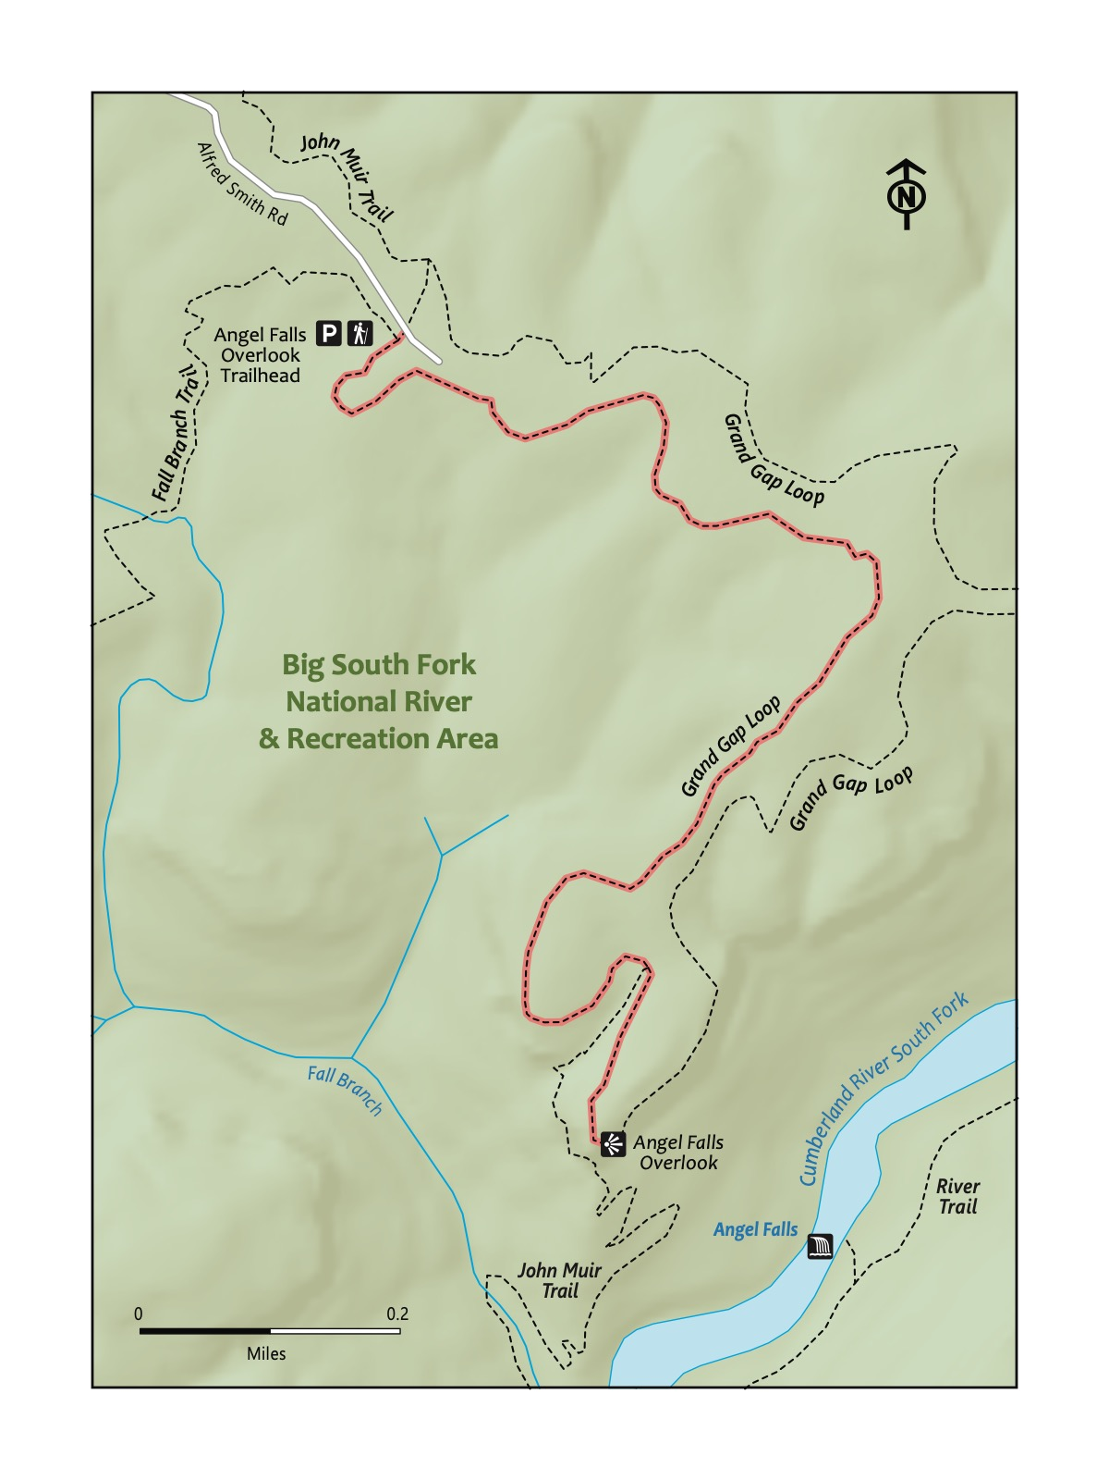

### Directions to the Trailhead

Trailhead Address: Grand Gap Loop Trailhead, G84V+69 Oneida, Tennessee

Trailhead GPS Coordinates: 36.50549, -84.65664

This address is for the trailhead for the Grand Gap Loop, deep into the Big South Fork National River & Recreation Area. The address uses a Google Maps “Plus code,” as there is not a street address for the trailhead. Please note this only works for Google Maps. Turn right into the parking area from Alfred Smith Rd. Look for the Grand Gap Loop Trail to begin the hike.

|  |  |
| --- | --- |
|  | **Angel Falls**  Angel Falls is more a rapids than a waterfall, but there’s a history to its name: It was a waterfall until the 1940s, when it was dynamited to make the river more easily navigable by paddlers and boaters. It was only a little successful: the rapids are known as being impassable for all but the most intrepid whitewater paddlers. |

### Trail Description

| Distance from Start | Description |
| --- | --- |
| 0.0 | Start on the Grand Gap Loop (part of the John Muir Trail - these hikes share a name at this point). Head counterclockwise on the loop trail; the other direction is a much longer way to the overlook. |
| 0.85 | Grave site. |
| 1.0 | Descend gently toward the overlook. |
| 1.4 | Overlook. Rest and picnic at the large rocky overlook atop the Big South Fork and Angel Falls. Then, turn around to return to the start. |
| 2.8 | Trailhead. |

|  |
| --- |
| Photo credit to Katie and Joshua Rosenberg |

Photo credit to Katie and Joshua Rosenberg

### Nearby

* **Stop by Bandy Creek.** Check out the Bandy Creek chapter for more details.
* **Hike the Angel Falls Trail**—**and others.** The Angel Falls Trail—not to be mistaken with the trail taken to the overlook featured in this hike—starts at the parking area beside the Leatherwood Ford Bridge. It follows the Big South Fork River to conclude with a close-up view of Angel Falls, but without the vista from the overlook. Also, the Big South Fork National River and Recreation Area has more than 300 miles of trails.

# Trail 19 : Honey Creek

### Overview

We can’t make this hike up! This trail features rope ladders, wooden ladders, gigantic sandstone walls, a scenic overlook, a trail that traverses *up* a river, and boulders you crawl over and through. It’s spectacular and challenging. This is a memorable trail that exemplifies what makes the Cumberland Plateau region such a worthy complement to the Great Smoky Mountains National Park. Younger children may be able to hike the first half (traveling counterclockwise from the trailhead); you can walk the road back to the trailhead. The second half of the trail contains more challenging (but very beautiful) sections. Still, it’s hard – probably the most difficult for most in this book, making it best for the older kiddo hiker. Oh, and you will definitely want to be prepared to get your feet wet on this hike!

|  |
| --- |
| Photo credit to Sam Weisbrod |

Photo credit to Sam Weisbrod

### Key Characteristics

| **Characteristic** | **Details** |
| --- | --- |
| Time Estimate | 4 hours - 7 hours |
| Trail Distance (Miles) | 4.4 |
| Elevation Change | Steep |
| Pets | Not Allowed |
| Parking Pass/Entrance Fee | Required |
| Restroom(s) | No |
| Best Ages |  |
| Strollers and Wheelchairs |  |

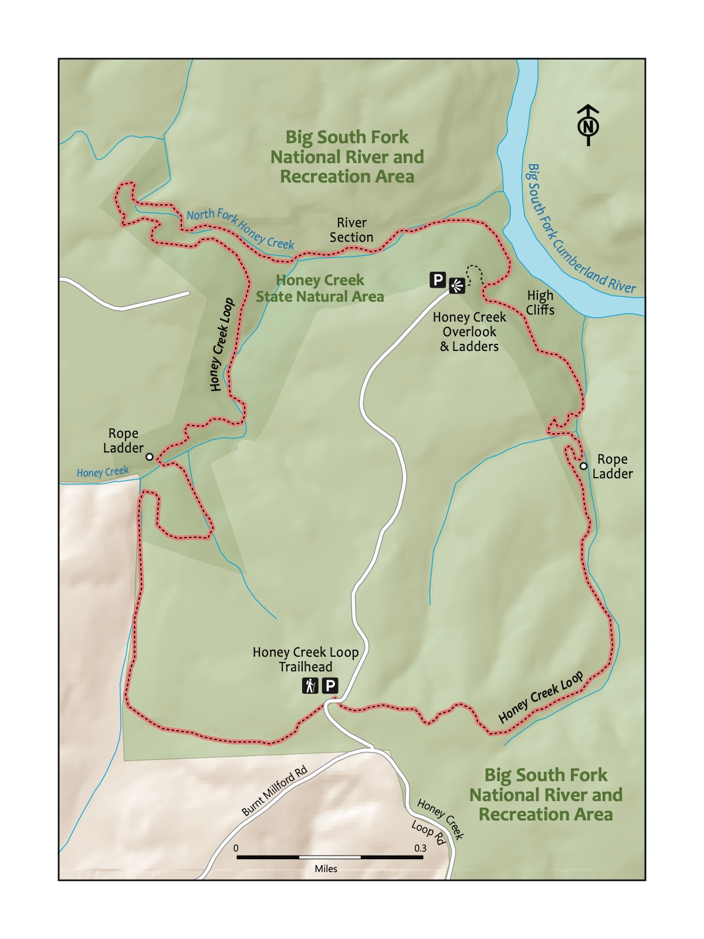

### Directions to the Trailhead

Trailhead Address: Honey Creek Trailhead and Parking Area, C8CX+G7 Allardt, Tennessee

Trailhead GPS Coordinates: 36.42123, -84.65180

Navigate to the Honey Creek Trailhead. Note that there is also a Honey Creek Overlook, which is the incorrect start for this hike. The above address uses a Google Maps “Plus” code in lieu of a street address for this trailhead; it only works in Google Maps.

Park in one of the many spots at the trailhead. The trail begins slightly past the trailhead, on the other side of the road from the large signpost for the trailhead, slightly up the road. Look for the Honey Creek Loop Trail sign.

### Trail Description

| Distance from Start | Description |
| --- | --- |
| 0.0 | Start on the Honey Creek Loop Trail. Gently wind through the densely wooded forest. |
| 0.2 | Gently, then more steeply, descend through the woods. |
| 0.9 | Rope ladder. |
| 1.05 | Enter the section with high cliff walls along the left of the trail. |
| 1.35 | Trail splits to the left to head to the overlook. Ladders. |
| 1.45 | Overlook. After stopping at the overlook, head back down to resume the trail by turning left at the trail juncture. Or, optionally, walk the road back 0.8 miles to the parking area and trailhead. |
| 1.75 | Trail turns up into Honey Creek. Look for the green symbol with two hikers as a guide to follow the trail; in places, you’ll walk through the creek and through crevices and cracks in giant boulders! |
| 2.25 | Head up and away from the creek. |
| 2.75 | Wind through and around huge boulders and rocks. Continue to look for the green trail symbols. |
| 3.0 | Ice Castle Falls, a beautiful waterfall. |
| 3.1 | Gentle climb through a rocky, exposed section with different vegetation. |
| 3.25 | Short rope ladder. |
| 3.3 | Trail levels out, then climbs back to the start and the trailhead. |
| 4.4 | Trailhead. |

|  |
| --- |
| Photo credit to Katie and Joshua Rosenberg |

Photo credit to Katie and Joshua Rosenberg

### Nearby

* **Grab a slushie!** This is one of the most remote—if not the most remote—hikes in this book. A favorite stop on the way back from Honey Creek is to quench our thirst by enjoying a slushie at the Pilot Travel Center (106 Comfort Ln, Pioneer, TN 37847) off exit 122 on I-75.

# Trail 20: Spruce Flats Falls in Smoky Mountain National Park

### Overview

An adventurous hike in the Smokies accessible to many families, this hike is also a great introduction to the national park, particularly when visiting from around Knoxville (it’s fairly close). It’s on the Great Smoky Mountains Institute site at Tremont, a national leader in outdoors and environmental education. It is the first hike in this section for a good reason. The proximity to Townsend is a bonus. Best for little kids and big kids. We have hiked this trail with a two-month-old baby in wrap carrier! Just take your time and watch your footing. This, at times, challenging hike is well worth it!

|  |
| --- |
| Photo credit to Katie and Joshua Rosenberg |

Photo credit to Katie and Joshua Rosenberg

### Key Characteristics

| **Characteristic** | **Details** |
| --- | --- |
| Time Estimate | 1.5 hours - 2.5 hours |
| Trail Distance (Miles) | 1.6 |
| Elevation Change | Moderate |
| Pets | Not Allowed |
| Parking Pass/Entrance Fee | Required |
| Restroom(s) | Yes |
| Best Ages |  |
| Strollers and Wheelchairs |  |

(This map is being worked on still)

### Directions to the Trailhead

Trailhead Address: 9275 Tremont Rd, Townsend, TN 37882

Trailhead GPS Coordinates: 35.64000, -83.68905

The address and coordinates are for the Great Smoky Mountains Institute, as this is the easiest-to-locate destination. When nearly there (less than a quarter of a mile from the destination), you’ll cross a bridge to enter the Institute. You’ll see a lot of parking around, as well as a gift shop. Though the trailhead and Google Maps will navigate you a little further, the parking you see here is the best place to park. From this parking lot, walk up the road a little toward the Spruce Flats Falls Trailhead to start the hike.

### Trail Description

| Distance from Start | Description |
| --- | --- |
| 0.0 | Though the main trail you take to the falls is the Buckeye Trail, you will start the hike on the Lumber Ridge Trail. Ample signage is available to help avoid confusion. |
| 0.1 | Turn right onto the Buckeye Trail. |
| 0.15 | Trail levels out before a steep climb. |
| 0.3 | Climb begins. It’s a (good) challenge! |
| 0.5 | High point of the hike in a piney outcropping. Good photo spot. Begin to wind down toward the waterfall. |
| 0.8 | Spruce Flat Falls. A great snack or picnic spot. After a nice break, turn around the way you came. |
| 1.6 | Trailhead. |

|  |
| --- |
| Photo credit to Faith Wood |

Photo credit to Faith Wood

### Nearby

* **Stop at the Tremont store.** The gift store at Tremont (the full name is the Great Smoky Mountains Institute at Tremont) is usually open Monday—Friday from 10:00 a.m.—4:00 p.m.
* **Hike the West Prong trail.** This is a great nearby trail to a great picnic spot (at the site of Backcountry Site #18, across the road from the Great Smoky Mountains Institute at Tremont.
* **Visit Townsend.** See Chestnut Tops trail for more detail.

# Trail 21: Little River

### Overview

This hike is a great introduction to the Great Smoky Mountains National Park by featuring a bit of many of the elements that make the Smokies special — a trail along a beautiful, clear river; a waterfall; abundant plant and aquatic wildlife; deep forest; and human history in the form of historic cabins. It’s close to many amenities, and the drive from Knoxville is doable in a day. The hike starts at the Little River trailhead, following the Little River along its namesake river. Turn around near the small waterfall or continue the loop back to the trailhead. Great for kids of all ages because there is not any one spot you must reach on the trail; hike as far as you like and then head back to the start to picnic or check out the historic cabins!

|  |
| --- |
| Photo credit to Katie and Joshua Rosenberg |

Photo credit to Katie and Joshua Rosenberg

### Key Characteristics

| **Characteristic** | **Details** |
| --- | --- |
| Time Estimate | 3 hours - 5 hours |
| Trail Distance (Miles) | 5.5 |
| Elevation Change | Moderate |
| Pets | Not Allowed |
| Parking Pass/Entrance Fee | Required |
| Restroom(s) | No |
| Best Ages |  |
| Strollers and Wheelchairs |  |

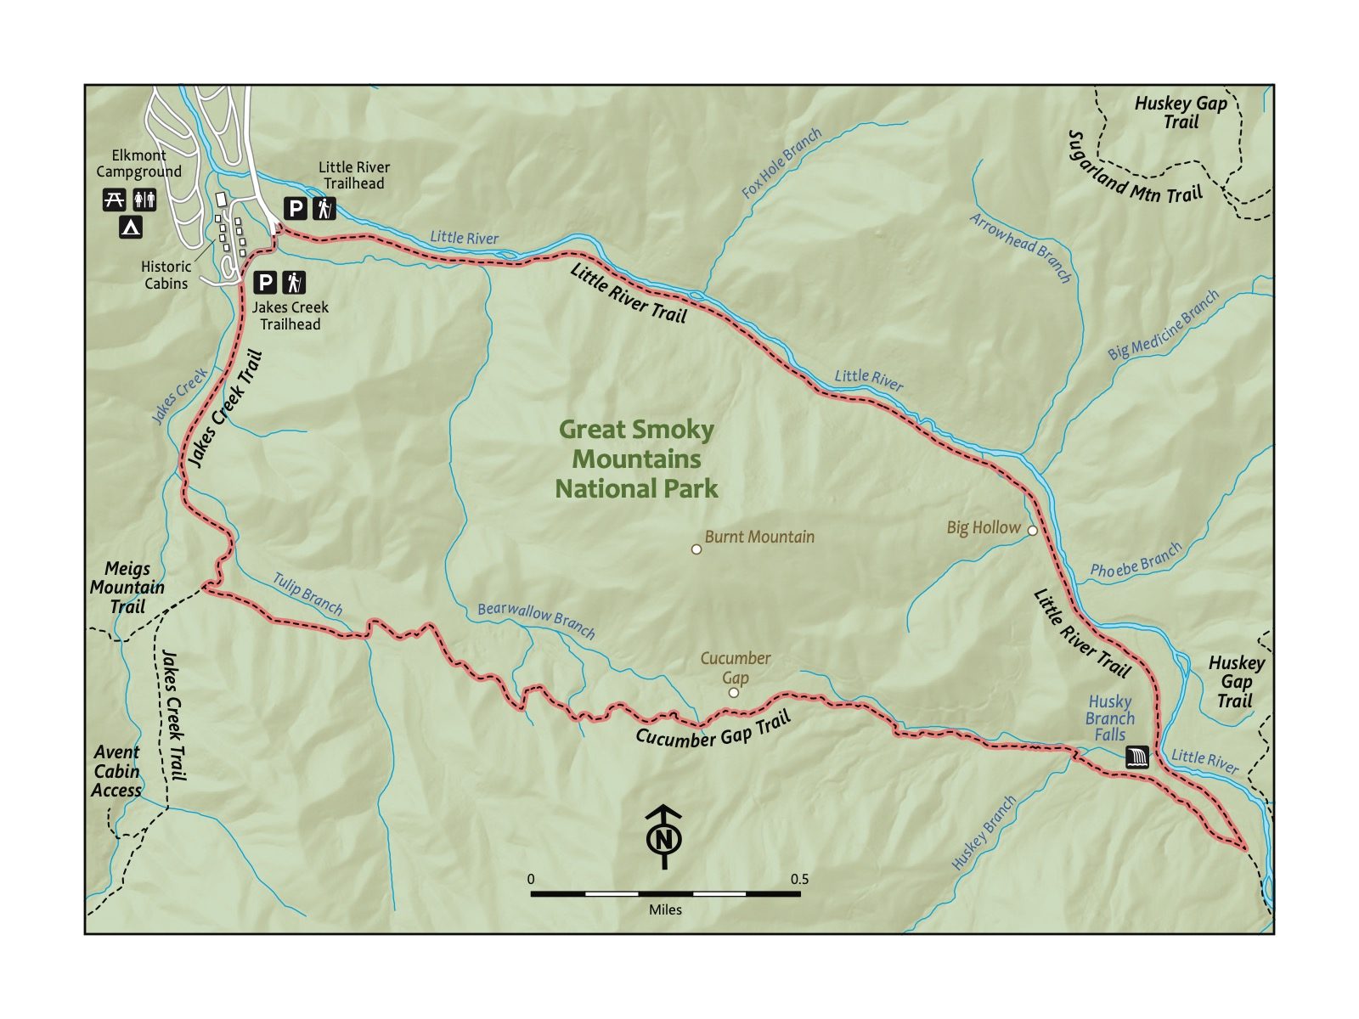

### Directions to the Trailhead

Trailhead Address: Elkmont Campground, MC58+3H Gatlinburg, Tennessee Trailhead GPS Coordinates: 35.65346, -83.58005

Trailhead GPS Coordinates: 35.65346, -83.58005

The trailhead address includes a “Plus code” to park at the start of the Little River Trail — that parking area does not have a specific address. If you navigate to “Elkmont Campground,” then look for signs to the parking for the Little River Trail, where this hike begins. Park and look for the gate across the gravel road, where the Little River Trail begins.

|  |  |
| --- | --- |
|  | **Eastern Hemlock**  A tree that “feels” like the Smokies - likes shaded groves. Characterized by its needles being arranged in a flat frond. Threatened by an invasive species, the Hemlock Wooly Adelgid. While many trees in the region are affected (look for a white dusty covering of needles), others are not. |

### Trail Description

| Distance from Start | Description |
| --- | --- |
| 0.0 | Pass around the gate (it’s closed only to vehicles) to begin on the Little River Trail. |
| 0.1 | Pass the Spence Cabin, a histotic cabin that is available to rent (for the day — not for nights!). |
| 0.45 | Trail begins to ascend. |
| 2.1 | Huskey Branch Falls on the right side of the trail. |
| 2.4 | Reach the intersection of the Little River Trail and the Cucumber Gap Trail. Turn right onto the Cucumber Gap trail. Trail climbs up toward Cucumber Gap. |
| 3.4 | Cucumber Gap — the high point of this hike. Begin to descend. |
| 4.65 | Reach the intersection of Cucumber Gap Trail and Jakes Creek Trail. Turn right onto Jakes Creek Trail. |
| 5.3 | Reach Jakes Creek Road. Turn right to return to the trailhead. |
| 5.5 | Trailhead. |

|  |
| --- |
| Photo credit to Katie and Joshua Rosenberg |

Photo credit to Katie and Joshua Rosenberg

### Nearby

* **Visiting historic cabins.** The nearby historic cabins are a must-see. Kids love to duck into and out of many recently restored (and others in the process of being restored).
* **Camping at Elkmont campground.** The Elkmont Campground is scenic, large, and worth a visit, especially if you can reserve a spot beside the Little River.

# Trail 22: Mouse Creek

### Overview

Surprisingly close to Knoxville, given how remote and wild this trailhead and trail feels, Mouse Creek in the Big Creek area of the Smokies is quite a bit less well-known than many of the other trails in the Great Smoky Mountains National Park in this book. The creek that this trail follows looks otherwordly - clear and almost turquoise in color. This hike starts at a trailhead at the Big Creek Picnic Area — beside the Big Creek Campground. The trail starts off a little steep, but the trail is wide and smooth; like the Middle Prong trail, this trail used to be a railroad bed. The trail follows above the creek and then returns closer to it, with Mouse Creek Falls as the turn-around. A good day-trip adventure for kids and families; the smooth grade makes this an achievable hike for younger littles.

|  |
| --- |
| Photo credit to Katie and Joshua Rosenberg |

Photo credit to Katie and Joshua Rosenberg

### Key Characteristics

| **Characteristic** | **Details** |
| --- | --- |
| Time Estimate | 2 hours - 4 hours |
| Trail Distance (Miles) | 4.0 |
| Elevation Change | Moderate |
| Pets | Not Allowed |
| Parking Pass/Entrance Fee | Required |
| Restroom(s) | Yes (seasonal) |
| Best Ages |  |
| Strollers and Wheelchairs |  |

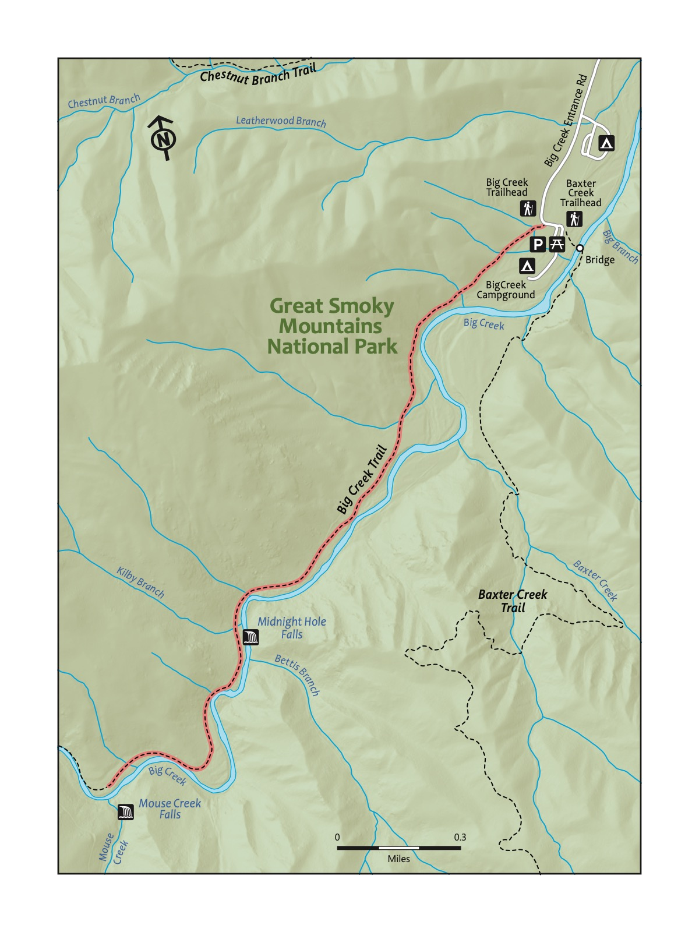

### Directions to the Trailhead

Trailhead Address: Big Creek Picnic Area, QV2R+H6 Newport, Tennessee Trailhead GPS Coordinates: 35.75132, -83.10964

Trailhead GPS Coordinates: 35.75132, -83.10964

Navigate to the Big Creek Picnic Area. Note that the above address uses a Google Maps “Plus code” in the absence of a street address for this picnic area; the plus code only works in Google Maps. The picnic area is at the end of a bumpy dirt road; it’s large and easy to find. You may note the Big Creek Trailhead on the way (it was on the right, immediately before the parking lot). Park and then backtrack a little on the road you took to the parking area to find the start of this trail. Kids may like to play around the picnic area (and the pretty bridge crossing Big Creek) before or after the hike!

|  |  |
| --- | --- |
|  | **Blue Ridge Two-Lined Salamander**  The Great Smoky Mountains has more than 30 species of salamanders – one of the types of species that contributes to and characterizes the incredible biodiversity of the Smokies. The Blue Ridge Two-Lined Salamander is among the most beautiful salamanders, with its yellow-to-orange coloring and stark black stripes. - Amanda Garner |

### Trail Description

| Distance from Start | Description |
| --- | --- |
| 0.0 | Start on the Big Creek Trail. Gradually ascend. |
| 0.1 | Ascend grardually on a wide path. |
| 1.4 | Midnight Hole Falls. Great swimming spot in the summer. |
| 2.0 | Mouse Creek Falls. Turn-around spot. Head back to the start. Optionally, continue farther on the trail. |
| 4.0 | Trailhead. |

|  |
| --- |
| Photo credit to Dean Pennala |

Photo credit to Dean Pennala

### Nearby

* **Picnicking at a lovely picnic area.** The Big Creek Picnic Area is one of the finest spots to picnic in the Great Smoky Mountains National Park. Start or end your hike with a picnic here.

# Trail 23: Whiteoak Sink

### Overview

This is the wildflower hike in the Smokies. It’s a joy in mid-late April, depending on the year’s weather. This hike starts on the kid-friendly Schoolhouse Gap trail and then connects to the Whiteoak Sink trail, which is a bit rockier but still hike-able by younger children. You may notice that Whiteoak Sink does not appear on the National Park Service trail map for the Smokies; technically, Whiteoak Sink is not an official trail in the Great Smoky Mountains National Park, and the key takeaway for hikers is to respect this unique area of the park by staying on the trail and refraining to pick wildflowers. It is a must-hike during wildflower season, but also worth a trip outside of that elusive spring period. Because of the length, best for younger kids who are carried some or all of the way, or kids who are comfortable with a longer hike.

|  |
| --- |
| Photo credit to Katie and Joshua Rosenberg |

Photo credit to Katie and Joshua Rosenberg

### Key Characteristics

| **Characteristic** | **Details** |
| --- | --- |
| Time Estimate | 3 hours - 5 hours |
| Trail Distance (Miles) | 4.6 |
| Elevation Change | Moderate |
| Pets | Not Allowed |
| Parking Pass/Entrance Fee | Required |
| Restroom(s) | No |
| Best Ages |  |
| Strollers and Wheelchairs |  |

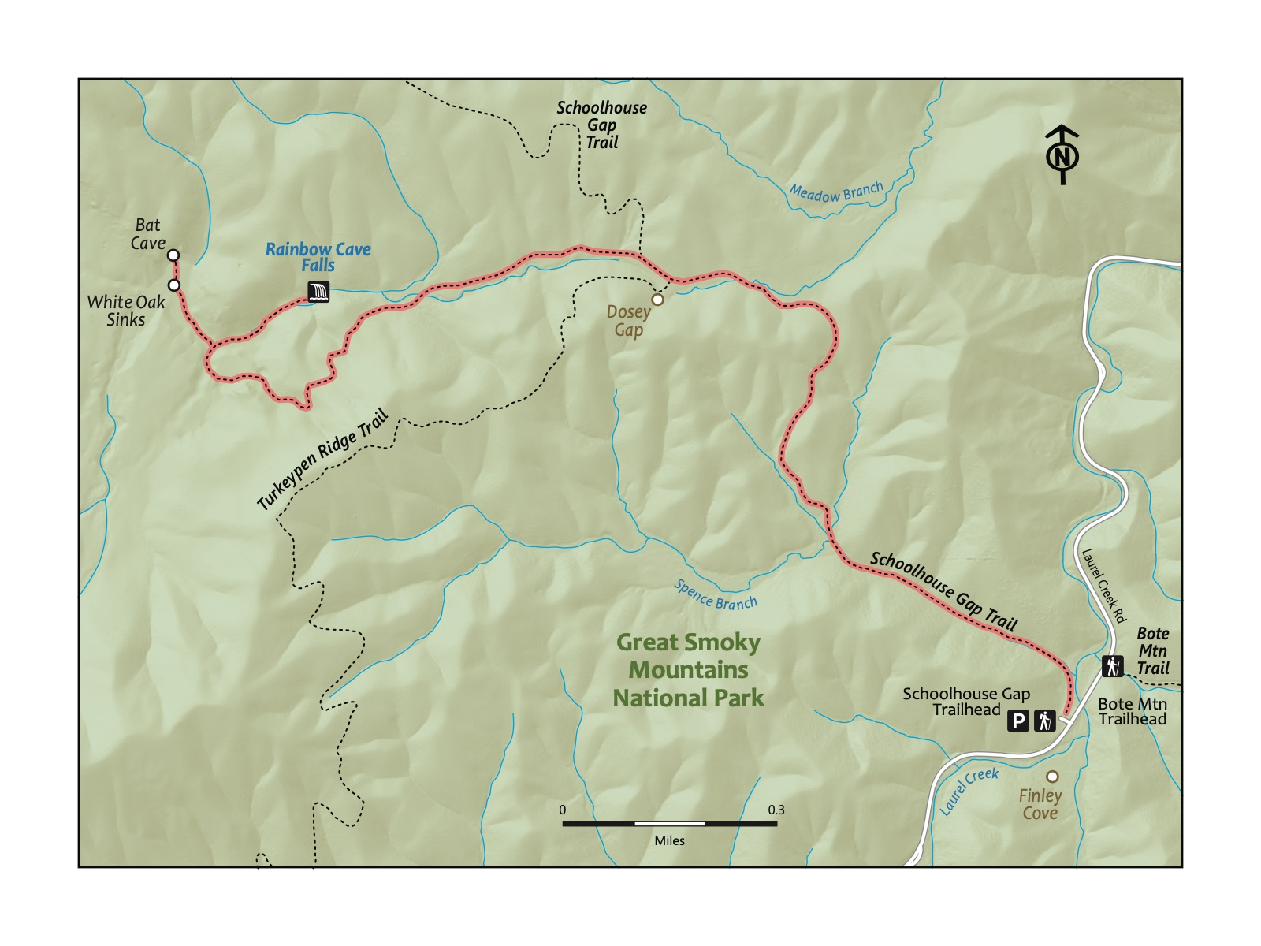

### Directions to the Trailhead

Trailhead Address: Schoolhouse Gap Trailhead, J7GF+W9, Townsend, TN 37882 Trailhead GPS Coordinates: 35.62718, -83.72650

Trailhead GPS Coordinates: 35.62718, -83.72650

The above address is for the parking area beside the trail. Please note it uses a Google Maps “Plus code”, as this trailhead does not have a street address. This plus code only works in Google Maps. Park, and look for several large boulders next to a sign for the Schoolhouse Gap Trail to begin the hike.

|  |  |
| --- | --- |
|  | **Trillium**  Native perennial plants with distinctive three-petal flowers that bloom in the spring. These shade-loving plants are often found in the forest understory, where their seeds are dispersed and buried by ants, in a process called myrmecochory. Trillium plants are protected in many places because they are extremely slow-growing. For some species, it can take anywhere from 5-9 years from being planted to their first bloom; a single plant can live up to 25 years! So, next time you see one, make sure you appreciate their beauty with your eyes only. - MaryRose Weatherton |

### Trail Description

| Distance from Start | Description |
| --- | --- |
| 0.0 | Start on the Schoolhouse Gap Trail. Trail very gradually ascends. |
| 0.4 | Trail climbs more steeply (but managably!). |
| 1.1 | Intersection with the trail to Whiteoak Sink. Note that Whiteoak Sink is not an official trail on the official trail map for the Great Smoky Mountains National Park; thus, the trail is not as well marked as most others. Turn left from the Schoolhouse Gap trail onto the trail to Whiteoak Sink. Descend for around .25 miles. |
| 1.4 | Ascend steeply through a pretty and densely wooded forest. |
| 1.7 | High point. Descend into Whiteoak Sink. |
| 1.9 | Reach an intersection. The trail to the right heads to Rainbow Cave Falls (different from and not to be confused with the Rainbow Falls Trail near Gatlinburg!). After stopping at the waterfall, turn around to return to the intersection of the primary trail. |
| 2.2 | Turn right back onto the primary trail. Enter the part of the trail with the densest understory of wildflowers. Tread carefully; stay on the trail to not damage any of the plants near to the trail. |
| 2.35 | Reach the large bat cave ahead of the end of the trail. Still tread carefully (and do not attempt to enter the caves for your safety and to not endanger the bats). Optionally, turn right or left to explore more of this special area. Then, turn around to return along the trail you took into Whiteoak Sink. Return to the start. |
| 4.6 | Trailhead. |

|  |
| --- |
| Photo credit to Katie and Joshua Rosenberg |

Photo credit to Katie and Joshua Rosenberg

### Nearby

* ****Exploring the Cades Cove loop.**** A drive around the Cades Cove Loop can complement a hike to Whiteoak Sink. We recommend only driving this beautiful loop road outside of the busiest times (summer and fall weekends and holidays, mainly) when traffic can be intense. Consult the Abrams Fall hike for additional details on this area and nearby amenities.
* ****Visiting Townsend.**** Like the Chestnut Tops hike, visiting “The Peaceful Side of the Smokies,” Townsend, is a great way to end this trip to the Great Smoky Mountains National Park.
* ****Hiking the West Prong Trail.**** The nearby West Prong Trail is a favorite that didn’t quite make it into this book, but it is still a worthy destination. Instead of hiking up Schoolhouse Gap (like for this trail), cross the road and hike to the scenic backpacking site #18 as the turn-around spot beside a wood log bridge and pretty creek.

# Trail 24: Middle Prong

### Overview

This hike is great for families looking to have an authentic hiking experience deep in the Smokies while still being only a little over an hour’s drive from Knoxville. A benefit of this hike is its distance–only 0.6 miles to the waterfall, but along a stream that affords many chances to hop in and splash. The turn-around spot is an overlook to a waterfall, Lynn Camp Prong, though the trail continues after the cascades up to another waterfall, Indian Flats Falls. Given the ample shade and easy access to the stream, this is a great hike for the summer, but it is enjoyable in all seasons. Good for kids of all ages.

|  |
| --- |
| Photo credit to Katie and Joshua Rosenberg |

Photo credit to Katie and Joshua Rosenberg

### Key Characteristics

| **Characteristic** | **Details** |
| --- | --- |
| Time Estimate | 4 hours - 6 hours |
| Trail Distance (Miles) | 7.6 |
| Elevation Change | Moderate |
| Pets | Not Allowed |
| Parking Pass/Entrance Fee | Required |
| Restroom(s) | No |
| Best Ages |  |
| Strollers and Wheelchairs |  |

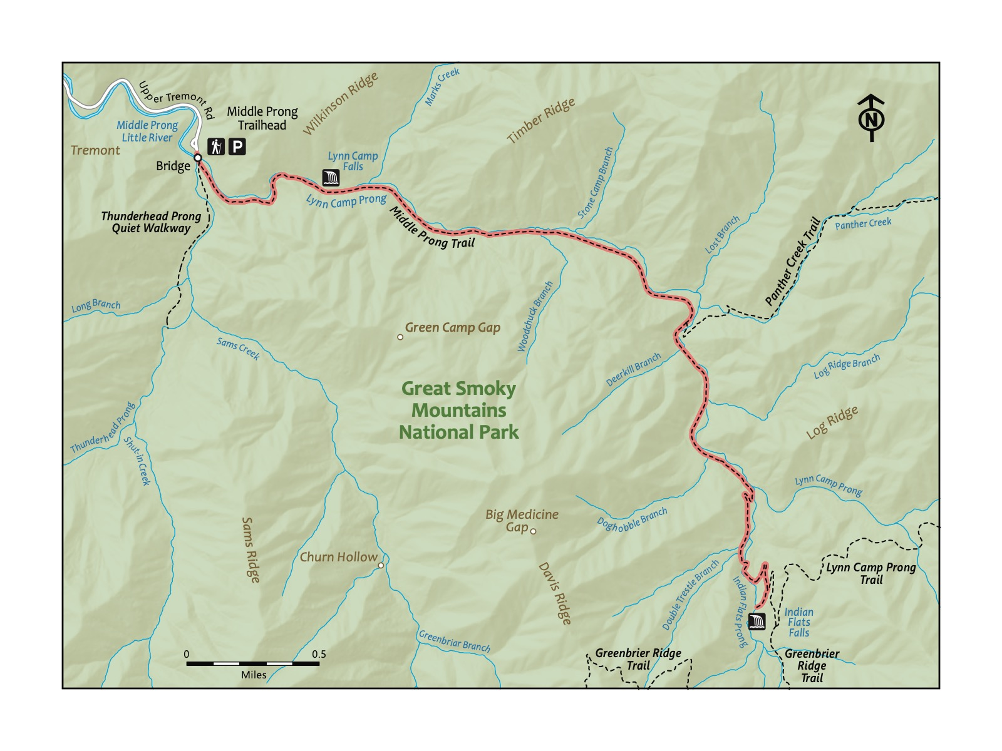

### Directions to the Trailhead

Trailhead Address: Middle Prong Trail Trailhead, J89J+54 Townsend, Tennessee Trailhead GPS Coordinates: 35.61794, -83.66971

Trailhead GPS Coordinates: 35.61794, -83.66971

The above address will navigate you to the parking area for the trailhead. Please note it uses a “Plus code” in lieu of a stree address that only works in Google Maps. Note that this trailhead is at the end of a lengthy gravel road, but it’s fairly smooth (and it’s a pretty drive). This is a large parking area. Even on the busiest days, you will be able to find a place to park. There are spots around the turn-around, but, if they are taken, it is acceptable to park on the side of the road. After parking, walk toward the bridge to start your hike.

|  |  |
| --- | --- |
|  | **Brook Trout**  The native species of trout in Smokies streams. Speckled and small. Found at high elevations, whereas the Rainbow Trout and Brown Trout were later introduced for fishing. |

### Trail Description

| Distance from Start | Description |
| --- | --- |
| 0.0 | Cross the bridge over Lynn Camp Prong. Ascend gradually on the Middle Prong Trail. |
| 0.05 | Almost immediately past the bridge, not the split in the trail. This hike heads to the left. A short trail, the Thunderhead Prong Quiet Walkway, heads to the left (it’s a great place for kids to play and splash on hot days!). |
| 0.65 | Overlook to Lynn Camp Prong. Though a short way in, this is an acceptable spot to turn around and head back to the start. The trail continues onward. This is one of many trails in the Smokies that is pretty and very worthwhile all along the way; hike as far as you or your littles like. |
| 2.35 | Intersection with Panther Creek Trail on the left. Continue on the Middle Prong Trail. |
| 3.6 | Begin a brief switchback before the waterfall at the end of this hike. |
| 3.8 | Reach Indian Flat Falls. Look for a little opening in the trees and shrubs. You’ll find it! After resting at the beautiful waterfall, turn around to return to the start. |
| 5.25 | Intersection with the Panther Creek Trail on the right. |
| 7.6 | Trailhead |

|  |
| --- |
| Photo credit to Katie and Joshua Rosenberg |

Photo credit to Katie and Joshua Rosenberg

### Nearby

* Driving the Cade’s Cove Loop. This is a nice way to make a longer day of your trip. Instead of returning the way you came, at the intersection of Townsend Road and Laurel Creek Road, turn left and head toward Cade’s Cove. The drive to Cade’s Cove is around 15 minutes; the loop road around Cade’s Cove takes around 45 minutes to drive–longer on busy days, especially when bears are visible–which is often! Traffic on the loop road can be severe, especially during peak times, so plan accordingly to avoid restless kiddos.
* **Stopping for a snack or meal in Townsend.** Townsend bills itself as the “Peaceful Side of the Smokies”. Peaceful Side Social is a favorite lunch and dinner spot with kids, owing to the good food and large outdoor play area.

# Trail 25: Abrams Creek

### Overview

Abrams Creek is a great place to start hiking in the Smokies if you live in or around Knoxville. It’s accessible, offers a wide variety of features to please all members of the family, and has the added bonus of being beautiful! The enduring memory from this trail is of kids splashing endlessly in the shallow creeks. This was the first place we traveled as a family in the Smokies, and we returned again and again because we always enjoyed our time together there. There are many ways to shorten the hike, and we often hike around a mile in and then turn around. It can be warmer here in the summer months, but the river offers many opportunities to swim and splash around, making it a great destination for the summer as well. This hike is relatively challenging and better suited to hiking with older children, but the beauty of this hike is its versatility.

|  |
| --- |
| Photo credit to Sam Weisbrod |

Photo credit to Sam Weisbrod

### Key Characteristics

| **Characteristic** | **Details** |
| --- | --- |
| Time Estimate | 4 hours - 6 hours |
| Trail Distance (Miles) | 5.8 |
| Elevation Change | Moderate |
| Pets | Not Allowed |
| Parking Pass/Entrance Fee | Required |
| Restroom(s) | Yes (seasonal) |
| Best Ages |  |
| Strollers and Wheelchairs |  |

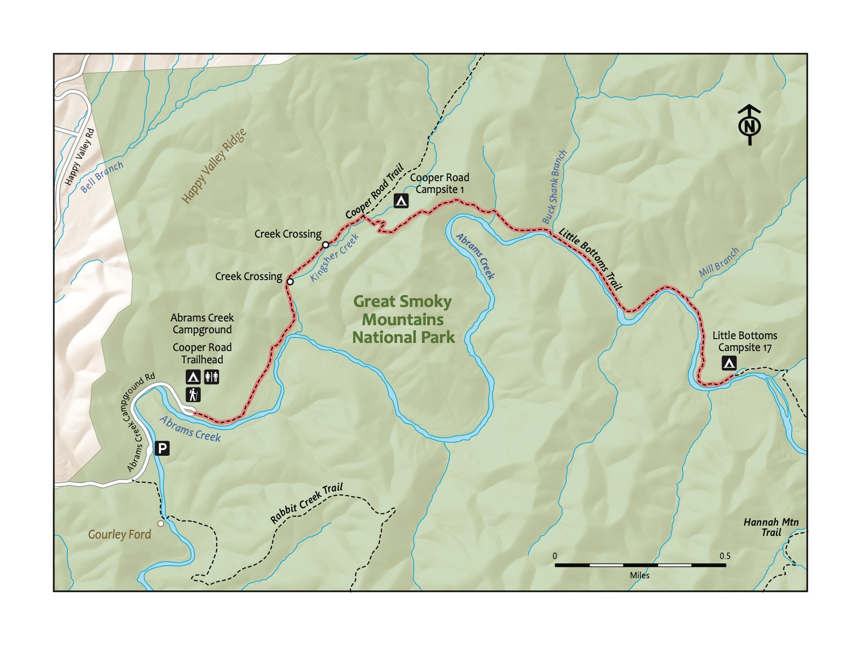

### Directions to the Trailhead

Trailhead Address: Abrams Creek Campground, J368+MR Tallassee, Tennessee Trailhead GPS Coordinates: 35.61095, -83.93356

Trailhead GPS Coordinates: 35.61095, -83.93356

It never seems to become crowded at Abrams Creek, but parking can be a bit confusing. This is because the campground is further along the same road the trailhead is on. Also, there are two areas to park for the trailhead. We usually park by the gate to the campground, but you can also park near the large sign with maps of this area of the national park.

### Trail Description

| Distance from Start | Description |
| --- | --- |
| 0.0 | Start at the trailhead parking area. Walk along the road beside Abrams Creek. |
| 0.4 | Arrive at the campground. A great spot to rest and hang out by the creek. |
| 1.0 | Cross Kingfisher Creek for the first time. Watch for rocks and branches to aid in crossing. |
| 1.1 | Cross Kingfisher Creek again about 100 yards past the first crossing. |
| 1.3 | Reach Backcountry Site #1. Frequently used by overnight backpackers; a good resting spot. We often turn around here! |
| 1.5 | Reach the top of the ridge after a steep climb. Another great place to stop and rest (or turn around). Or continue for a grand adventure. |
| 1.6 | Arrive at the overlook with views of Abrams Creek and Gregory Bald in the distance. |
| 2.0 | Return to Abrams Creek near its intersection with Buckshank Branch. A great spot to relax and splash in the creek. |
| 2.8 | Reach Backcountry Site #17. Turn around here to head back to the start. |
| 4.3 | Return to Backcountry Site #1. |
| 5.6 | Trailhead. |

|  |
| --- |
| Photo credit to Katie and Joshua Rosenberg |

Photo credit to Katie and Joshua Rosenberg

### Nearby

* **Visiting the Look Rock Overlook.** Check the Look Rock Overlook hike for a short, nearby hike to a pretty overlook.
* **Camping at Abrams Creek Campground.** This is a lovely creekside campground that you pass on this hike. Consider a stay in the summer, when jumping in the cool, not-too-deep creek can be a respite from the heat—or in the fall when this area pops with fall colors.

# Trail 26: Look Rock

### Overview

This is a short but rewarding overlook hike that is just a moderate drive from Knoxville. The entire hike is paved — but the trail is steep. Start at a parking area with a very scenic overlook. The trail starts steep but then levels out. At the top is a tower that affords views of the Smokies as well as the Tennessee Valley and Knoxville. Clear days are more often found in the winter, spring, and fall (after the humidity drops). Consider coupling with a drive along the Foothills Parkway, or take visitors here after you pick them up from the airport in nearby Maryville, as we have with our parents! This is a fun family thike with littles that serve as a nice and usually not crowded introduction to the Smokies.

|  |
| --- |
| Photo credit to Katie and Joshua Rosenberg |

Photo credit to Katie and Joshua Rosenberg

### Key Characteristics

| **Characteristic** | **Details** |
| --- | --- |
| Time Estimate | 30 minutes - 1 hour |
| Trail Distance (Miles) | 0.6 |
| Elevation Change | Moderate |
| Pets | Not Allowed |
| Parking Pass/Entrance Fee | Required |
| Restroom(s) | No |
| Best Ages |  |
| Strollers and Wheelchairs |  |

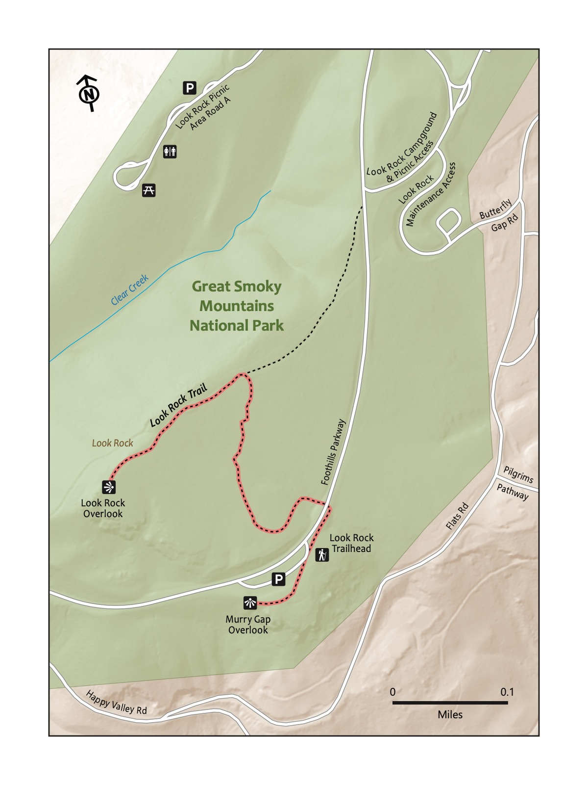

### Directions to the Trailhead

Trailhead Address: Look Rock Lower Overlook, 7210 Flats Rd, Tallassee, TN 37878 Trailhead GPS Coordinates: 35.63099, -83.94083

Trailhead GPS Coordinates: 35.63099, -83.94083

The above address takes you to a large parking lot with a scenic overlook. Park, and look for the scenic overlook—the Murry Gap Overlook. From there, walk along the back of the parking lot, and then along a sidewalk. Cross the road to the Look Rock Trail to begin the hike.

### Trail Description

| Distance from Start | Description |
| --- | --- |
| 0.0 | Start at the Murry Gap Overlook. |
| 0.15 | Cross the road to the Look Rock Trail. |
| 0.35 | Intersection. Turn left to continue on the Look Rock Trail. |
| 0.4 | Weather station to the right. Continue on the trail. |
| 0.5 | Reach the overlook. Climb the ramp to reach the top—and take a look in all directions! Return back down the ramp to return to the start. |
| 0.65 | Intersection. Turn right to return to the parking lot and trailead. |
| 1.0 | Trailhead. |

### Nearby

* **Visiting Abrams Creek.** See the Abrams Creek hike for a nearby, lengthier expedition.
* **Driving the Foothills Parkway.** On the way to the trailhead for this hike, you briefly drove on the Foothills Parkway—Tennessee’s scenic parkway that receives far fewer visits than the well-known Blue Ridge Parkway. But this is an underrated road featuring scenic overlooks of the Smokies and limited traffic. Drive from here to Walland or Wears Valley and then turn back; or head home from there.

# Trail 27: Chestnut Top

### Overview

Steep but quiet and rewarding, Chestnut Top is a fun choice for a shorter hike in the Great Smoky Mountains National Park. This hike is one of the closest to Knoxville. Furthermore, it is close to the amenities of Townsend — a far quieter town than Pigeon Forge and Gatlinburg. The trail starts with a steep climb until it reaches a rocky point that is a great stopping point; we always grab a snack here, and kiddos like to hike on or around the rocks. The trail continues along the trail past pretty mountain laurel, typically in bloom around mid-May through early June, stopping at a fun but somewhat arbitrary point - a hollow tree! Continue farther if you like, or head back to the start and the Townsend Wye, a great picnic and water play spot. Best for kids who are comfortable with a steady climb.

|  |
| --- |
| Photo credit to Katie and Joshua Rosenberg |

Photo credit to Katie and Joshua Rosenberg

### Key Characteristics

| **Characteristic** | **Details** |
| --- | --- |
| Time Estimate | 1.5 hours - 2.5 hours |
| Trail Distance (Miles) | 2.6 |
| Elevation Change | Steep |
| Pets | Not Allowed |
| Parking Pass/Entrance Fee | Required |
| Restroom(s) | No |
| Best Ages |  |
| Strollers and Wheelchairs |  |

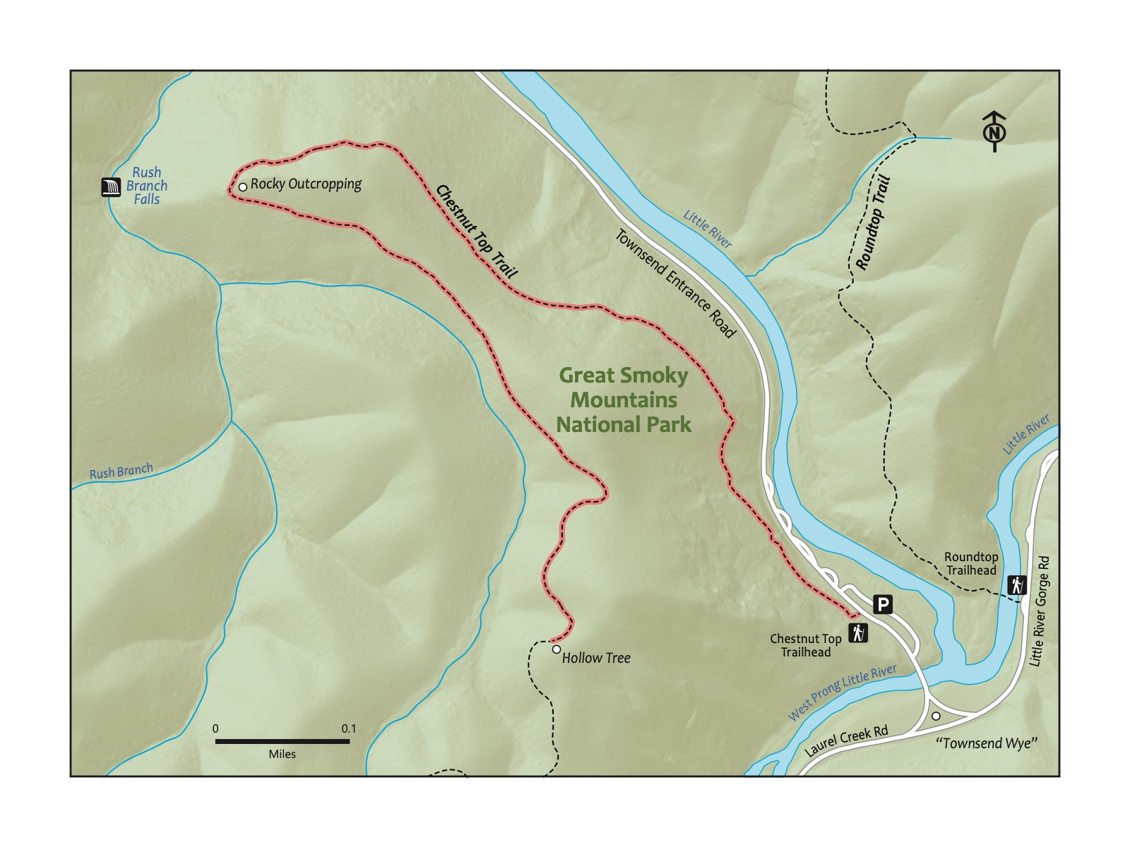

### Directions to the Trailhead

Trailhead Address: Townsend Wye, Laurel Creek Rd & Little River Rd, Townsend, TN 37882 Trailhead GPS Coordinates: 35.66027, -83.70839

Trailhead GPS Coordinates: 35.66027, -83.70839

This address is for the Townsend Wye, a prominent intersection between Townsend, the road to Gatlinburg (Little River Gorge Rd.), and the road to Cades Cove (Laurel Creek Road) and one of the best-known summer swimming spots in the Smokies. Park in the large parking area on the left of the Townsend Entrance Rd. on which you entered if coming from Knoxville and Townsend. The trail begins across the Townsend Entrance Rd. — look for a sign across the road for the Chestnut Top Trail.

### Trail Description

| Distance from Start | Description |
| --- | --- |
| 0.0 | Start on the Chestnut Top Trail. Ascend steeply. |
| 0.6 | Trail levels out. Townsend visible from the trail. |
| 0.70 | Rocky outcropping. Great place for a break and for kids to scramble up and around the rocks. Look for Mountain Laurel a little bit up the trail that flowers around May and June. |
| 1.3 | Hollow Tree. This is the turn-around spot for this hike. Alternatively, if you like, head farther up the trail! |
| 2.6 | Trailhead. |

### Nearby

* **Visiting Townsend.** Townsend rightly contrasts itself with busy Pigeon Forge and Gatlinburg—it remains quiet but full of places to stop. We love the kid-friendly Peaceful Side Social (7967 E Lamar Alexander Pkwy, Townsend, TN 37882) and the next-door Peaceful Side Creamery.
* **Swimming at the Townsend Wye.** This is a classic summertime Smokies activity. From the large parking area near the trailhead, swim in the Little River beside the Townsend Wye—the three-way intersection of Townsend Entrance Road (toward Townsend), Laurel Creek Road (to Cades Cove), and Little River Gorge Road (toward Gatlinburg).

# Trail 28: Abrams Falls

### Overview

This is a classic Smokies hike along the scenic Abrams Creek, ending in an epic waterfall. The only downside? You must drive (or, on Wednesdays in the summer, bike!) through Cades Cove to get to the trailhead, and Cades Cove is often busy. We recommend either being prepared for extensive traffic in Cades Cove or visiting during the week or outside of the busy warm weather weekends. With that caveat in mind, we recommend this as a true day-long family adventure worthy of a visit. The trail starts at a scenic trailhead near the intersection of two pretty creeks. it hikes through the piney forest, climbing a little at a few points. Abrams Falls is a wonderful spot for a lengthy picnic before returning to the start. Best for older children or younger children who are carried when their little legs get tired.

|  |
| --- |
| Photo credit to Katie and Joshua Rosenberg |

Photo credit to Katie and Joshua Rosenberg

### Directions to the Trailhead

Trailhead Address: Abrams Falls Trailhead, H4RW+CX Townsend, Tennessee Trailhead GPS Coordinates: 35.59129, -83.85233

Trailhead GPS Coordinates: 35.59129, -83.85233

Navigate to this parking area at the end of a short gravel road connected to the Cades Cove Loop Rd. Lots of parking. Look for a sign pointing toward the Abrams Falls Trail and Abrams Fall.

|  |
| --- |
| Note |
| A symbol of the wildness of the Smokies – and a very real presence. If you see one, admire their strength, beauty, and intelligence (from a distance!). |

### Trail Description

| Distance from Start | Description |
| --- | --- |
| 0.0 | Start on the Abrams Fall Trail, crossing a bridge over the scenic Abrams Creek soon after you start. |
| 0.1 | Wind along the path through a pine forest. |
| 1.1 | Rocky prominence that serves as a scenic overlook. |
| 2.2 | Small hill beside and atop Abrams Falls. Take the trail briefly, steeply down to the bottom of the waterfall. |
| 2.5 | Reach the base of the waterfall. There are many spots to stop and snack or picnic. Take care to watch from a distance and not swim in the pool of the falls here; the undertone is dangerous. After a break, turn around to begin the back portion of this out-and-back hike. |
| 5.0 | Trailhead. |

### Nearby

* **Visiting the visitor center.** The Cades Cove Visitor Center (5686 Cades Cove Loop Rd, Townsend, TN 37882) up the road is a store, but it also abuts several nearby historical structures that are worth a visit)—the Cades Cove Historical Grist Mill and the John P Cable Drive Thru Barn (that you walk, rather than drive, to and through!). Try to find your way to Mill Creek to cool off in warm weather.
* **Stopping at historic cabins and scenic lookouts.** Though it can be busy with traffic, especially during peak visitation periods (summer and fall weekends, in particular), a drive through Cades Cove is punctuated with numerous opportunities to stop at historic cabins and scenic lookouts. Plus, much of the year, you and others will stop to see wildlife—deer, turkey, and often bears!
* **Bike the Cades Cove Loop.** Biking the Cades Cove Loop on car-free Wednesdays during the summer and into the early fall is a classic Smokies activity. We know it’s a lot for kids to bike (or be carried out on a bike) and to hike, so this may be best as a separate day trip.

|  |
| --- |
| Photo credit to Katie and Joshua Rosenberg |

Photo credit to Katie and Joshua Rosenberg

# Trail 29: Andrews Bald

### Overview

Andrews Bald is the under-rated twin to Kuwohi (formerly known as Clingman’s Dome). Kuwohi is the highest point in the Great Smoky Mountains National Park — the highest point in Tennessee and among the highest in the Eastern United States. Why Andrews Bald instead of Kuwohi? The path to Kuwohi is often exceptionally crowded. It is still worth a visit, but Andrews Bald is as or more exceptional in some ways: instead of reaching a crowded overlook, Andrews Bald is a grassy bald overlooking layers of mountains. Pair it with a trip to Kuwohi or a stop at Newfound Gap, perhaps catching sunset after an afternoon hike to Andrews Bald. One memorable experience for us: we saw a bear on this trail, our first as a family. The hike has some rocky elements, and it can be lengthy, so we recommend this hike for older children.

|  |
| --- |
| Photo credit to Katie and Joshua Rosenberg |

Photo credit to Katie and Joshua Rosenberg

### Key Characteristics

| **Characteristic** | **Details** |
| --- | --- |
| Time Estimate | 2 hours - 3.5 hours |
| Trail Distance (Miles) | 3.6 |
| Elevation Change | Moderate |
| Pets | Not Allowed |
| Parking Pass/Entrance Fee | Required |
| Restroom(s) | Yes (seasonal) |
| Best Ages |  |
| Strollers and Wheelchairs |  |

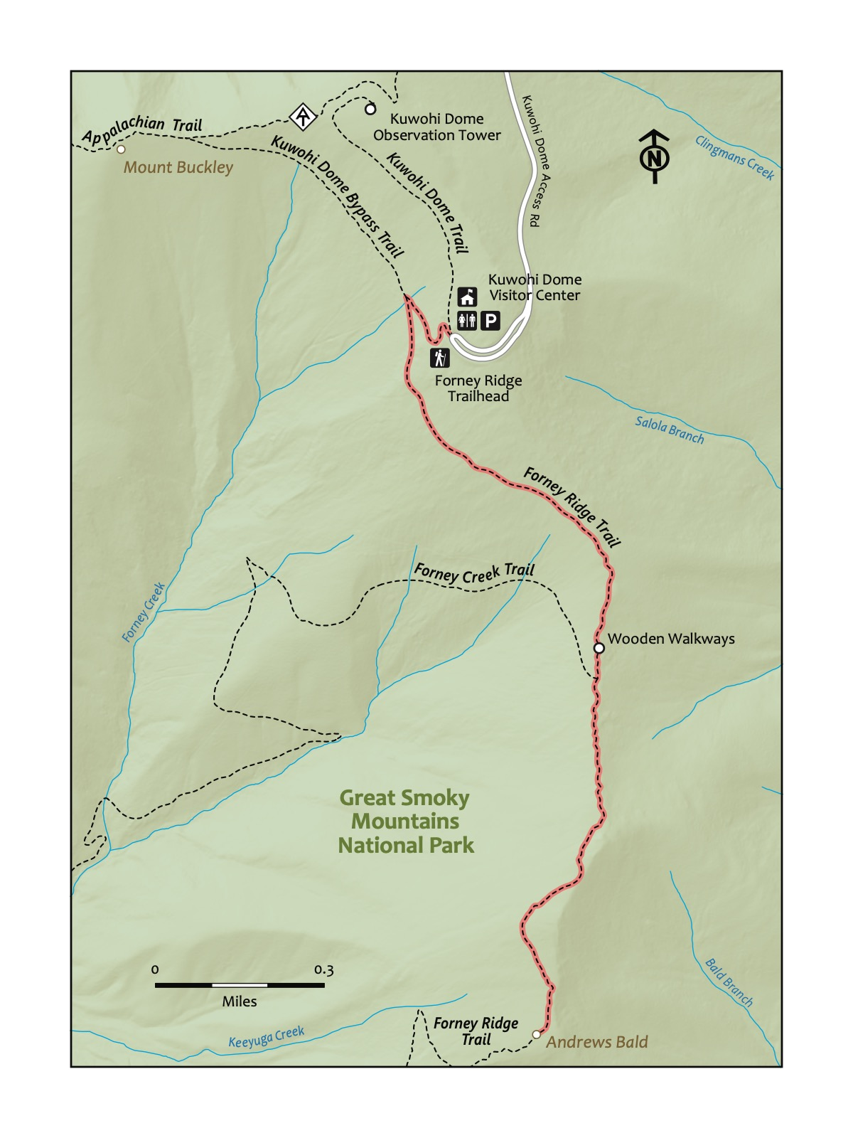

### Directions to the Trailhead

Trailhead Address: Kuwohi Trailhead, HG43+QG Bryson City, North Carolina Trailhead GPS Coordinates: 35.55680, -83.49617

Trailhead GPS Coordinates: 35.55680, -83.49617

The above address is for the trailhead for Kuwohi—formerly named Clingman’s Dome until renamed to its traditional name to the Cherokee, Kuwohi. in 2023. Parking here can be difficult to find during busy periods (especially during the summer, during breaks, and on weekends during the fall).

Consider visiting outside of these busy periods to avoid being stuck waiting to find a spot. After finding a spot, walk toward the Kuwohi Visitor Center. Look for the signs for the Forney Ridge Trail (it’s just a few feet to the left along the same path as the Kuwohi Trail).

|  |  |
| --- | --- |
|  | **Fraser Fir**  You’ll feel like you’re in a different state or country when you spot these trees atop the Smokies – usually at elevations above 5,500 feet. Note the “Christmas tree smell”! Afflicted by the Balsam Wooly Adelgid and potentially a changing climate around the ridge of the Smokies, including Kuwohi, you’ll note both dead and diseased and healthy specimens. Recent evidence suggests that the Fraser Firs are healthier as a population than 20-30 years ago. |

### Trail Description

| Distance from Start | Description |
| --- | --- |
| 0.01 | Start on the Forney Ridge Trail. |
| 0.2 | Intersection with the Kuwohi Bypass Trail. Turn left. |
| 0.25 | A moderately rocky but well-maintained section that descends. Steep in sections. |
| 1.0 | Wooden walkways over a section that can be muddy. |
| 1.05 | Intersection with the Forney Creek Trail — different from the Forney Ridge Trail. Stay on the Forney Ridge trail to continue to Andrews Bald. |
| 1.8 | Andrews Bald. Explore the super-scenic, grassy area before turning back. |
| 2.55 | Intersection with Forney Creek Trail. Stay on the Forney Ridge Trail. |
| 3.4 | Intersection with the Kuwohi Bypass Trail. Turn right. |
| 3.6 | Trailhead. |

|  |
| --- |
| Photo credit to Katie and Joshua Rosenberg |

Photo credit to Katie and Joshua Rosenberg

### Nearby

* **Visiting Kuwohi (Clingman’s Dome).** Nearby Kuwohi and the Kuwohi Trail to access this peak feature an observation tower with views in all directions. There’s also the nearby Kuwhohi Visitor Center. Both the trail and visitor center share the same parking area.
* **Stopping at Newfound Gap.** On the way to Andrews Bald, you passed Newfound Gap—the mountain pass and scenic overlook atop the state line between Tennessee and North Carolina. This is a good place to stop for photos or a brief (or lengthier!) hike on the Appalachian Trail that runs through the parking lot—and toward the popular scenic overlook Charlie’s Bunion, a steep, challenging eight-mile round-trip hike from Newfound Gap.

# Trail 30: Alum Cave Bluffs

### Overview

This is a hike up arguably *the* finest trail in the Great Smoky Mountains National Park. The trail starts at a pretty trailhead along Highway 441, the main road through the park. The trail continues along the super scenic Alum Cave Creek; the trail is very well-maintained and easily hiked by younger children. The trail climbs through a unique geological feature you hike *through*, Arch Rock, then heads up more steeply toward Mt. LeConte. The trail then crosses an overlook surrounded by Mountain Laurel before climbing farther toward Alum Cave, yet another unique geological feature, Alum Cave, you hike *beneath.* It’s epic. This is a perfect spot for a rest and a picnic before returning to the trailhead. This is a challenging hike, and finding parking can also be a challenge, but it is worth the investment of time and effort, particularly for older kids or little kids looking for a big challenge.

|  |
| --- |
| Photo credit to Katie and Joshua Rosenberg |

Photo credit to Katie and Joshua Rosenberg

### Key Characteristics

| **Characteristic** | **Details** |
| --- | --- |
| Time Estimate | 3 hours - 5 hours |
| Trail Distance (Miles) | 4.5 |
| Elevation Change | Very Steep |
| Pets | Not Allowed |
| Parking Pass/Entrance Fee | Required |
| Restroom(s) | Yes (seasonal) |
| Best Ages |  |
| Strollers and Wheelchairs |  |

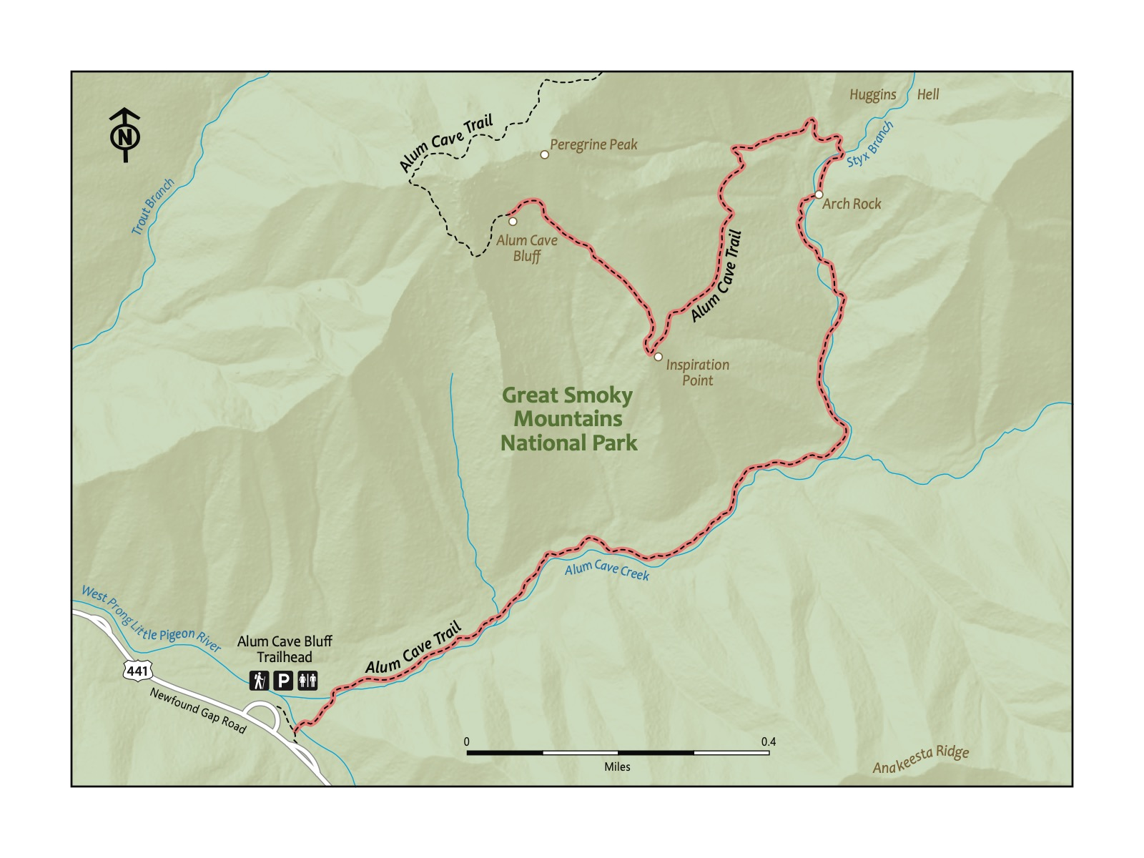

### Directions to the Trailhead

Trailhead Address: Alum Cave Trailhead Parking Area, 3639 Newfound Gap Rd, Gatlinburg, TN 37738 Trailhead GPS Coordinates: 35.62872, -83.45076

Trailhead GPS Coordinates: 35.62872, -83.45076

This is one of the busiest parking areas and trailheads in the park. Particularly with children, visiting during periods that are less busy can be essential for quickly finding a spot. Apart from visiting outside of busy periods, arriving in the early-mid afternoon can be a good time, as many who arrived in the morning are departing. Try to park at one of the two parking areas immediately beside the trailhead (one alongside the road, the other near the seasonal toilet). If you cannot, other parking is available, but from those you have to walk along the side of the road to reach the trailhead. If two or more adults are present, consider dropping children off with one adult, while the other finds a spot. After finding a spot, look for the signs for the Alum Cave Trail.

|  |  |
| --- | --- |
|  | **Jordans Red Cheek**  These iconic Smokies salamanders are found only in the Smokies! If you are above 2,500 ft, you might just see one of these amazing critters. - Amanda Garner |

### Trail Description

| Distance from Start | Description |
| --- | --- |
| 0.0 | Start on the Alum Cave Trail. Almost immediately cross a bridge over the West Prong of the Little Pigeon River. |
| 0.1 | Continue on the trail, now along Alum Cave Creek. The trail gradually climbs up a wide, scenic pathway, occasionally crossing |
| 0.6 | Fun spots to splash in the creek abound around this section. Pick one and cool off in warmer weather! |
| 1.3 | Cross a bridge and then climb up the stairs through Arch Rock. This is an optional point at which to turn-around and return to the start. |
| 1.4 | Cross a footlog and enter a different part of the hike, one where you will ascend more steeply (though the trail remains moderately steep here). |
| 1.9 | Reach inspiration point, a rocky prominence and scenic overlook — and a great point to pause or return back to the start, though the bluffs are only a bit further. |
| 2.2 | Steep climb up stairs. Almost there! |
| 2.25 | Alum Cave Bluffs. Rest, soak in the views, and get ready for the return hike (almost all downhill!). The trail to Mount LeConte continues past the bluffs. |
| 4.5 | Trailhead. |

|  |
| --- |
| Photo credit to Sam Weisbrod |

Photo credit to Sam Weisbrod

### Nearby

|  |  |
| --- | --- |
|  | **Red Spruce**  Similar to Fraser Fir, but larger (taller and wider) and found at lower elevations (beginning around 4,000 feet). Majestic. When you see them, you feel like you’re in high and remote mountains. |

* **Visit Sevierville, Pigeon Forge, and Gatlinburg.** Sevierville, Pigeon Forge, and Gatlinburg loosely form a corridor from I-40 to the entrance to the Great Smoky Mountains National Park. Sevierville and (especially) Pigeon Forge feature tourist attractions, restaurants, and a very wide variety of shops; Gatlinburg is touristy but has a more small-town character. As tourist destinations, all three can be busy, but they can be fun places to stop with happy but tired kiddos.
* **Hiking on to LeConte for a grand adventure!** You may continue farther along on the Alum Cave Trail to Mount LeConte, a peak with only around 40 feet less height than Kuwohi, but only accessible via (lengthy) hikes—the roundtrip hike from the Alum Cave Trail Trailhead to Mount LeConte is around 11 very challenging miles. There is a lodge at which you can reserve a rustic room—LeConte Lodge (LeConte Lodge · Gatlinburg, TN 37738)—but it can be difficult to secure a reservation. The LeConte Lodge includes a store at which day hikers can purchase snacks, coveted t-shirts, and even more coveted no-bake cookies.

|  |
| --- |
| Photo credit to Katie and Joshua Rosenber |

Photo credit to Katie and Joshua Rosenber

# Top 5 Hikes

Here are some hikes that we recommend for different reasons–and ages of kids.

### For Hiking With Babies and Infants

*These hikes are great when a short distance and a paved path are a priority.*

1. High Ground Park
2. Knox-Blount Greenway
3. Lakeshore Park
4. UT Arboretum
5. Norris Dam

### Real Hikes for Little Explorers Walking on Their Own

*These are “real” hikes–you and your little will know it!–but they’re also a reasonable distance and with not-too-challenging terrain.*

1. Ijams Riverside
2. Seven Islands
3. Emory Falls
4. Abrams Creek
5. Chestnut Tops

### For Kids Who Need a Playground Nearby

*Who doesn’t love a hike that starts and ends at or near a playground?*

1. Lakeshore
2. Emory Fall
3. Ijams Riverside
4. Ijams Crag
5. Sequoyah Park

### Bigger Adventures for Bigger Kids

*More challenging hikes for kids who are ready for the next challenge; completing any of these is an achievement.””

1. Alum Cave
2. Andrews Bald
3. Honey Creek
4. Little River
5. Abrams Falls

### For Kids Who Love to Play in the Water

*These hikes are great in warmer weather; bring the right clothing and shoes and let ’em splash!*

1. Middle Prong
2. Abrams Creek
3. Spruce Flats Falls
4. Honey Creek
5. Mouse Creek

### Best Spots for a Picnic

*Each of these is a fantastic place to have a family picnic.*

1. Mouse Creek
2. Lakeshore
3. Seven Islands
4. Sequoyah Park
5. Ijams Crag

### Simply must-do!

*These hikes represent what makes our region so special.*

1. Seven Islands
2. Little River
3. Andrews Bald
4. Honey Creek
5. Alum Cave

# Deepening the Experience

### Go farther!

Many of the hikes in this book are but a small part of longer trails. For instance, the Alum Cave Bluffs hike in the previous chapter is around one-half of the way to the top of Mount LeConte, an epic hike to a truly majestic scenic overlook, Cliff Tops. You should try it after you develop confidence making it to the Bluffs. Particularly in the Smokies and the Cumberland Plateau, you can go (much) farther if you like. Which leads to our next two points.

### Camp

A great way to be closer to the hikes, and to have more time for lengthier excursions, is to camp. Here are some of our favorites; all of these are fantastic:

* *Frozen Head State Park, Big Cove Campground*: the ideal family campground, quiet, with giant boulders and a nearby creek for kids to splash in, clean restrooms, and a playground and even a rustic library nearby.
* *Smokies campgrounds, tent or recreational vehicle*: several of the nearby Smokies campgrounds accomodate both tents and recreational vehicles (i.e., campers)
  + Cades Cove: The place to camp if you want to explore or bike (on Wednesdays in the summer and early fall) the Cades Cove Loop
  + Elkmont: Sprawling, and a little less spread out feeling than Cades Cove, but also a bit more scenic. Look for a site along the Little River.
* *Smokies campgrounds, tent friendly*:
  + Cosby: A hidden gem and one of our family’s favorites, with perhaps the most featureful quiet nature trail (not officially a trail in the Smokies!) that is connected to the campground. Mostly tent spots; has just a few spots for recreational vehicles.
  + Abrams Creek: Small and tucket mostly along Abrams Creek, this is a fantastic place to tent camp, though it can get hot in the summer.
* *Bandy Creek Campground*: In the Big South Fork, this is a modern, spacious, friendly campground that seems to never approach being full. Close to many great hiking trails—and the horse stables.

### Backpack

Another way to deepen the experience is to backpack. If you’re a little uncertain, check out the book we recommend in the next chapter. In the Smokies, there are many shelters — three-sided buildings that can be fun destinations for little ones (no tents needed)! Here are some specific places that we think are great for a first trip:

Backcountry sites in the Smokies: - Backcounty site #1 - Backcountry site #17 - Backcountry site #18

Shelters in the Smokies: - Shelters: Kephart Shelter, Icewater Springs Shelter

|  |
| --- |
| Photo credit to Katie and Joshua Rosenberg |

Photo credit to Katie and Joshua Rosenberg

Backcountry sites at Frozen Head State Park:

- Bird mountain

Backcountry sites in the Big South Fork:

- waterfall at Honey Creek  
- site on the Grand Gap Loop

### Learn more about the science and history

There is much to learn. Science and history. Visiting in all seasons. Check the Recommended Resources chapter for more.

|  |
| --- |
| Photo credit to Katie and Joshua Rosenberg |

Photo credit to Katie and Joshua Rosenberg

### Invite friends and family to join

Some of our greatest joys hiking have come from inviting friends and family — especially those new to hiking.

|  |
| --- |
| Photo credit to Katie and Joshua Rosenberg |

Photo credit to Katie and Joshua Rosenberg

### Join local organizations

Here are two that advocate for the Smokies:

* Friends of the Smokies (https://friendsofthesmokies.org/)
* Smokies Life (https://smokieslife.org/)

The *Tennessee Conservationist* is a nice magazine for the Tennessee State Parks system.

### Visit local outdoors education centers

We have two nationally and internationally outdoors education centers nearby, one near Knoxville and one in the Smokies:

* Ijams (https://www.ijams.org/)
* Great Smoky Mountains Institute at Tremont (https://gsmit.org/)

# Recommended Resources

### Other regional hiking guides

Hiking Trails of the Great Smoky Mountains: Comprehensive Guide Kenneth Wise

Best Tent Camping: Tennessee: Your Car-Camping Guide to Scenic Beauty, the Sounds of Nature, and an Escape from Civilization Paperback, Johnny Molloy

Explorer’s Guide 50 Hikes on Tennessee’s Cumberland Plateau, Johnny Molloy

Five-Star Trails: Knoxville: 40 Spectacular Hikes in the Heart of East Tennessee, Johnny Molloy

### Backpacking

The Backpacking With Kids Handbook: Your down and dirty guide to fun outdoor adventures with your kids, Kenda Alexander

Monsters In The Woods: Backpacking With Children, Tim Hauserman

### History

Valley So Wild: A Folk History, Alberta & Carson Brewer Brewer

The Terra Incognita Reader: Early Writings from The Great Smoky Mountains, Edited by Anne Bridges, Russell Clement, and Ken Wise

Folklife along the Big South Fork of the Cumberland River: Of The Cumberland River, Benita J. Howell

### Science

A Natural History Guide: Great Smoky Mountains National Park, Donald W. Linzey

### Field guides

Wildflowers of the Smokies, Peter White

Trees of the Smokies, Steve Kemp

Reptiles and Amphibians of the Smokies, Stephen G. Tilley and James E. Huheey

### General advice on hiking and going outdoors with kids

Babes in the Woods: Hiking, Camping & Boating with Babies and Young Children, Jennifer Aist

The World Is Our Classroom, Cindy Ross

### Children’s books

Hike, Pete Oswald

# About the Authors

Katie Rosenberg is a parent and school librarian at L&N STEM Academy in Knoxville, TN.

Joshua Rosenberg is a parent and a faculty member in the College of Education, Health, and Human Sciences at the University of Tennessee, Knoxville.

# Acknowledgments

Thank you to Sam Weisbrod for contributing very many of the photos used in this book.

Thank you to the many friends and family members who provided feedback: Joel and Teri Rosenberg, XXX.

Thank you to Will Fontanez for creating the maps used in this book.

And, most importantly, thank you to our children, Jonah and Ayla, for being the best.

Thanks to Thomas Wells at UT Press.

# Appendix

### Leave no trace

# Leave No Trace Principles

1. **Plan Ahead and Prepare**
2. **Travel and Camp on Durable Surfaces**
3. **Dispose of Waste Properly**
4. **Leave What You Find**
5. **Minimize Campfire Impact**
6. **Respect Wildlife**
7. **Be Considerate of Other Visitors**

### First-Aid Kit

XXX

### Comprehensive First-Aid Kit

XXX

### Optional Items

Here are some optional items to consider:

1. Water clothes when hiking in warmer weather
   * water shoes (e.g., Crocs)
   * change of socks
   * change of clothes
2. Additional layers
   * long sleeve shirt
   * fleece
   * rain jackets
3. Trekking/hHiking poles–helpful for water crossings and steeper trails
4. Child carriers–depending on the age of the kiddo
5. Sunscreen–depending on the weather and the trail
6. Bug spray–often not needed
7. Whistles for backpacks
8. A small flashlight or headlamp
9. Field guides